QUICK & SPICY CHICKEN NOODLES  COOK TIME: 15 min  SOURCE:  #quick #spicy #comfort-food | 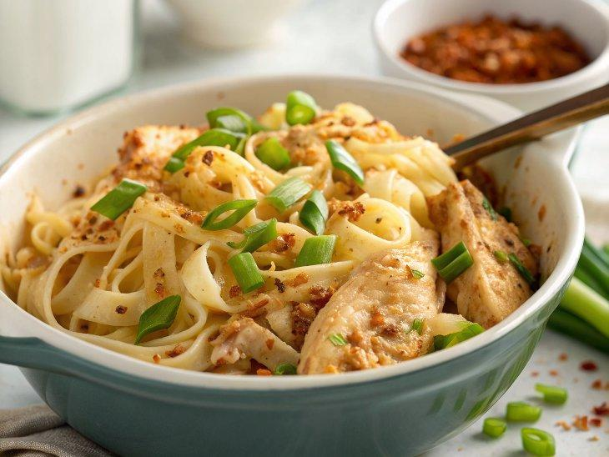

INGREDIENTS  - 2 leftover chicken legs  - 200 g dried pappardelle or flat Taiwanese noodles  - 4 garlic cloves crushed  - 2 spring onions white and green parts separated and finely sliced  - 1-1 1/2 tsp chilli flakes to taste  - 1 tbsp soy sauce  - 1 tsp dark soy sauce  - 1 tsp balsamic vinegar  - 1/2 tsp golden caster sugar  - 2 tbsp rapeseed oil | PREP  COOK  1. Remove the skin from the chicken and set aside. Cook the pasta or noodles following pack instructions, tearing in the chicken leg meat for the final 3 mins. Drain thoroughly and set aside. Mix the garlic, spring onion whites, chilli flakes, both soy sauces, the vinegar and caster sugar in a large heatproof bowl.  2. Put the chicken skin in a pan and sizzle over a medium-high heat for 3-4 mins, until crispy, then turn and, using the back of a fish slice, press down and cook for 2-4 mins more until crispy. Set aside on a plate lined with kitchen paper, then leave to cool slightly and crumble into pieces.  3. Set the pan of chicken fat over a medium-high heat and drizzle in the oil. Heat over a medium-high for 3-4 mins, until almost smoking. Remove from the heat and pour over the garlic and spring onion mixture, stirring well. Mix in the noodles and chicken, divide between bowls and sprinkle over the crispy chicken skin and spring onion greens.  PLATING

