LEBANESE-STYLE CINNAMON MEATBALLS RECIPE  COOK TIME: 30 min  SOURCE:  #comfort-food #meatballs #spiced | 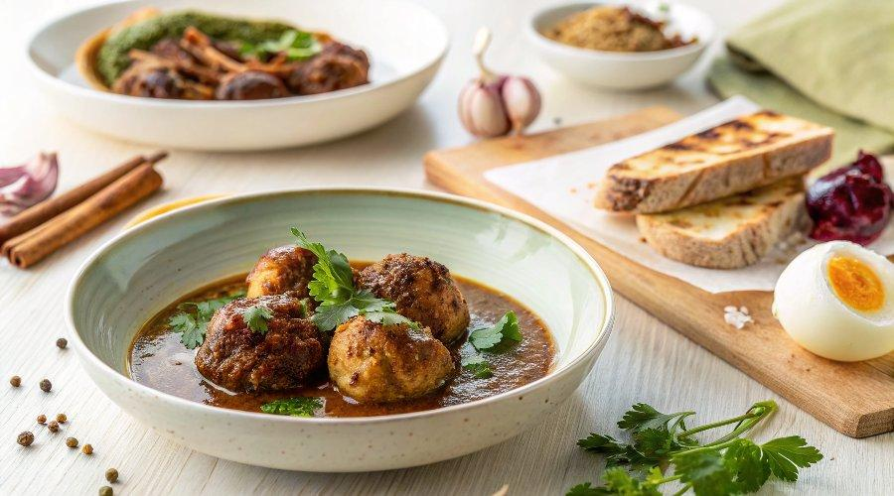

INGREDIENTS  - 1 slice sandwich bread, toasted to a golden brown  - 1/3 cup milk  - 1 1/2 lb quality grass-fed ground beef  - 1 egg  - 3/4 cup grated yellow onions  - 2 to 3 garlic cloves, crushed  - 1/2 cup packed fresh chopped parsley  - 1 tsp cinnamon  - 1 tsp ground allspice  - 1/2 tsp ground cardamom  - 1/2 tsp crushed red pepper (optional)  - Salt and pepper  - Private Reserve extra virgin olive oil  - 1 cup (240ml) grated yellow onion  - 2 garlic cloves, minced  - 1 carrot, finely grated  - 1 28-oz can quality crushed tomatoes  - 1/2 cup water  - 1 tbsp pomegranate molasses (optional)  - 2 bay leaves  - 1/2 tsp cinnamon  - 1/2 tsp allspice  - Salt and pepper  - Crushed red pepper flakes (optional, if you like a spicy sauce) | PREP  COOK  1. Preheat oven to 375°F (190°C), and prepare a large baking sheet lined with parchment paper.  2. In a small bowl, place the toasted bread and cover with the milk. Let the bread soak in the milk until very soft and mushy (about 15 minutes), then squeeze the bread well to wring all the milk out.  3. In a large mixing bowl, add the bread, ground beef, and the remaining meatballs ingredients. Using clean hands, mix/knead to combine.  4. Form the meat mixture into meatballs (each the size of a tablespoon.) Arrange the meatballs in one layer on the prepared baking sheet lined with parchment paper. Bake in 375°F (190°C) heated oven for 11 to 14 minutes or so. (don’t worry if they’re not fully done at this point, take them out and set aside)  5. While meatballs are baking, prepare the sauce. In a 5-quart braiser like this one or a large, deep saute pan like this one, heat 2 tbsp olive oil until shimmering but not smoking. Add the onions and cook over medium heat for 4 to 5 minutes, stirring regularly, until golden. Add the garlic and cook for a quick 30 seconds while tossing.  6. Now add carrots, crushed tomatoes and the remaining sauce ingredients. Bring sauce to a boil for 5 minutes or so, then lower heat.  7. Add the meatballs to the sauce, cover and let simmer for 20 minutes or so until the meatballs are fully cooked through. Garnish with chopped fresh parsley, if you like.  8. Serve in dinner bowls with Lebanese rice or warm pita. A side of fattoush salad is a great addition to this meal.  PLATING

