PEANUT BUTTER COOKIE BARS WITH BUTTERFINGER FROSTING  COOK TIME: 15 min  SOURCE:  #sweet #comfort-food #baking | 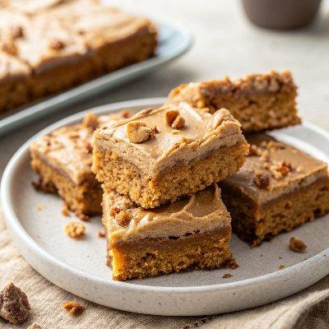

INGREDIENTS  - 1 cup (240ml) brown sugar  - 1 cup (240ml) granulated sugar  - 1 cup (2 sticks) butter, softened  - 1/2 cup crunchy peanut butter (*)  - 2 eggs  - 2 tsp vanilla extract  - 2 cups (480ml) all-purpose flour  - 2 cups (480ml) quick oats  - 1 tsp baking soda  - 1/2 tsp baking powder  - 1/2 tsp salt  - 1 tsp ground cinnamon  - 1 cup (240ml) smooth peanut butter  - 1/2 cup butter  - 1/2 cup unsweetened cocoa powder  - 2 3.7 oz. King Size Butterfinger Bars (finely crushed (I use my food processor),)  - 2 cups (480ml) sifted powdered sugar  - 1/2 tsp vanilla extract  - 1/3 cup evaporated milk (plus more as needed)  - 1/2 3.7 oz. King Size Butterfinger Bars (finely crushed (I use my food processor) | PREP  COOK  1. In a stand or electric mixer, cream butter and sugars until light and fluffy. Beat in 1/2 cup crunchy peanut butter. Add eggs and vanilla and mix until just combined.  2. In a separate bowl, mix together the Dry Ingredients until well combined. Add Dry Ingredients to Wet Ingredients and mix a few times then proceed to mix by hand (the dough will be thick) until evenly combined.  3. Lightly grease a large 12" x 17" jelly roll pan and add cookie dough. Spread dough out into an even layer.** Bake at 350F degrees for 12-15 or until edges are barely golden.  4. While the cookie is still hot, top with spoonfuls of 1 cup (240ml) smooth peanut butter. Let sit 30 seconds or so for the peanut butter to melt a little to become more spreadable. Once spreadable, smooth peanut butter evenly over cookie with a spatula. Let cool.  5. Meanwhile (you can do the first part while your cookie is baking), prepare Butterfinger Chocolate Frosting by melting butter in a medium saucepan. Stir in cocoa powder and bring to a boil for 1 minute. Let cool (I put mine in the refrigerator). Once cool, transfer to a mixing bowl and beat in Butterfingers, powdered sugar and vanilla until combined (it will be thick). Slowly beat in evaporated milk to reach desired consistency.  6. Spread frosting over cooled peanut butter layer. Sprinkle with crushed Butterfinger crumbs (optional).  PLATING

