HORSERADISH SAUCE RECIPE  COOK TIME: 2 min  SOURCE:  #quick #condiment #creamy | 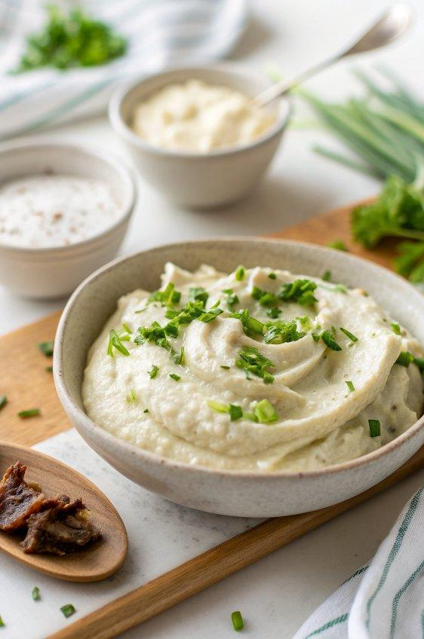

INGREDIENTS  - 1/2 cup sour cream  - 2 Tbsp prepared horseradish (drained)  - 2 Tbsp mayonnaise  - 1 tsp apple cider vinegar  - 1/4 tsp salt  - 1/8 tsp black pepper  - 1 Tbsp chives (finely chopped) | PREP  COOK  1. In a small mixing bowl, stir all of the ingredients together. Serve right away or cover and refrigerate for about 2 weeks.  PLATING

