LOW FAT STRAWBERRY NO-BAKE CHEESECAKE  COOK TIME: 30 min  SOURCE:  #no-bake #low-fat #quick | 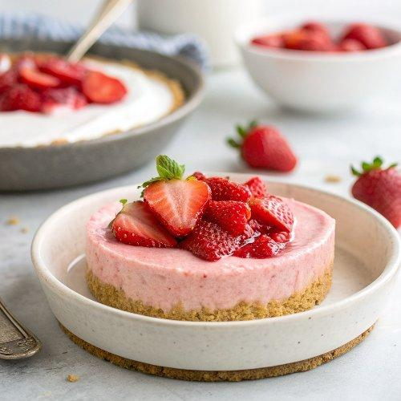

INGREDIENTS  - 8 oz Cool Whip Free  - 8 oz 1/3 less fat Philadelphia Cream Cheese  - 9-inch (23cm) reduced fat Graham Cracker Crust  - 1/4 cup sugar  - 2 tsp vanilla extract  - 12-14 strawberries (hulled and halved lengthwise) | PREP  COOK  1. In a large bowl, whip cream cheese, vanilla extract and sugar for a few minutes until fluffy.  2. Add Cool Whip and whip until smooth.  3. Spoon mixture into pie crust and chill for a few hours, until firm.  4. Arrange strawberries on top and serve.  PLATING

