JUMBO BUTTERNUT SQUASH RAVIOLI WITH KALE PESTO  COOK TIME: 10 min  SOURCE:  #comfort-food #pasta #homemade | 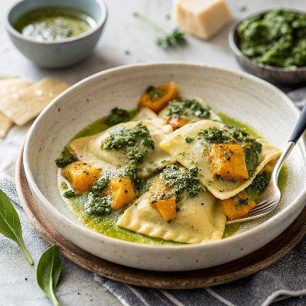

INGREDIENTS  - 1 whole butternut squash, peeled and cubed and roasted, OR steam-in-the-bag squash, totaling about 4 cups (960ml) cooked squash  - 1 cup (240ml) whole milk ricotta  - 1/2 cup grated Parmesan cheese  - 2 tbsp olive oil  - nutmeg, garlic, thyme, and/or sage (see notes)  - generous pinch of salt and pepper  - 1 beaten egg  - 1 package of round or square wonton wrappers (also gyoza wrappers) (about 50-60)  - Kale Pesto | PREP  COOK  1. Place cooked squash, ricotta, Parmesan, olive oil, seasonings, and S&P in a food processor. Pulse until mostly smooth. Mixture should be very thick and sticky, like cookie dough.  2. Bring a large pot of water to boil.  3. Lay out half of the wonton wrappers. Place 1-2 tablespoons filling in the center of each wrapper. Brush edges with egg wash. Place another wrapper on top, sealing tightly at the edges, and rounding the top with your palm to make a nice shape.  4. Boil ravioli in batches for about 5-8 minutes. Drain gently (they break easily) and toss with olive oil to prevent sticking. Serve with that yummy kale pesto and extra Parmesan cheese!  PLATING

