ANTIPASTO CHEESE BALL  COOK TIME: 30 min  SOURCE:  #cheese #party-food #savory | 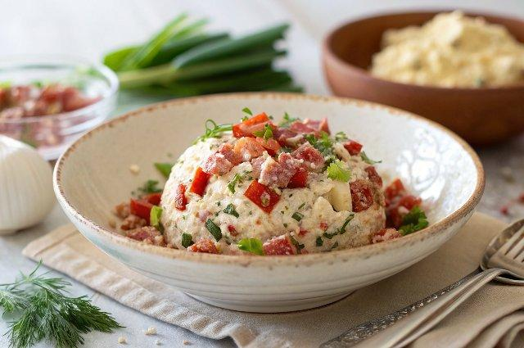

INGREDIENTS  - 24 oz cream cheese (softened)  - 1/2 cup sun-dried tomatoes (chopped)  - 1/2 cup red bell peppers (diced)  - 3.5 oz chopped salami pieces (chopped)  - 1/4 cup chives (chopped)  - 1/4 cup parsley (chopped)  - 1 tbsp onion powder  - 2 tsp garlic powder  - 1 pinch salt (to taste, if desired)  - 2 cups (480ml) pitted mixed olives (halved lengthways, I use a variety of black, green and Kalamata olives - dried with paper towel)  - 1/2 cup sun-dried tomatoes (chopped, dried with paper towel)  - 1 handful ritz (water crackers or pretzels for serving)  - 1 handful salami (slices, for serving)  - 1 handful prosciutto (slices, for serving) | PREP  COOK  1. In a bowl combine all the ingredients for the dip and mix until the ingredients are well combined.  2. Place a piece of non-stick plastic wrap on a clean bench top or work surface. Scoop the cream cheese mixture out onto the plastic wrap and completely cover with another piece of wrap.  3. Use your hands to mould the cream cheese mixture into a ball. Carefully pick up the cheese ball with one hand and peel off the plastic wrap on the bottom of the ball with your other hand. Place the ball straight onto a serving plate.  4. Decorate: dry each olive and sun dried tomato piece on a sheet of paper towel to soak up the oil before placing them on the cheese ball so they adhere better.  5. Lightly press them into the cream cheese to ensure they stay on. Brush with some sun dried tomato oil from the jar (optional but adds even more flavour)!  6. Serve with crackers of your choice, salami and prosciutto slices rolled up!ENJOY!  PLATING

