PICNIC BANH MI BAGUETTE  COOK TIME: 12 min  SOURCE:  #quick #sandwich #comfort-food | 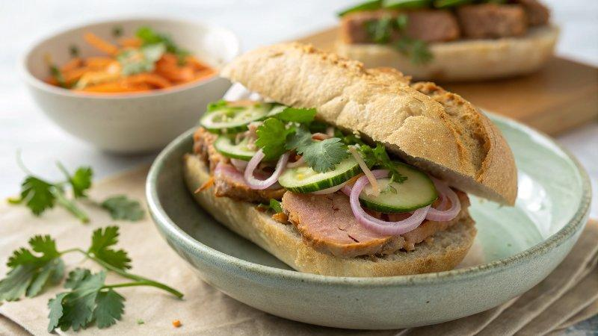

INGREDIENTS  - 2 bake-at-home sourdough baguettes  - 2 tbsp softened butter  - 100 g pâté  - 8 slices cooked pork loin  - 2 spring onions finely sliced  - 1/4 cucumber sliced  - handful of coriander chopped  - 6 tbsp rice vinegar  - 3 tsp caster sugar  - 100 g radishes sliced  - 1 carrot sliced into matchsticks  - 1 tbsp fish sauce  - 2 limes juiced  - 1 red chilli diced  - 2 tsp caster sugar | PREP  COOK  1. First, make the pickles. Heat the vinegar, 2 tbsp water and the sugar in a small pan over a low heat with a pinch of salt until steaming. Put the veg in a non-metallic bowl and pour over the hot vinegar mixture, then leave to pickle for at least 30 mins.  2. Bake the baguettes following pack instructions. Whisk the dressing ingredients together in a small bowl, taste and adjust, adding more sugar, lime or fish sauce, if needed.  3. Split the baguettes in half, then spread over the butter. Spread over the pâté, then layer up the pork loin, drained pickles, spring onions, cucumber and coriander. Spoon over some of the dressing, then serve with more on the side for dunking.  PLATING

