GLAZED CHOCOLATE DONUT HOLES  COOK TIME: 10 min  SOURCE:  #sweet #baked #chocolate | 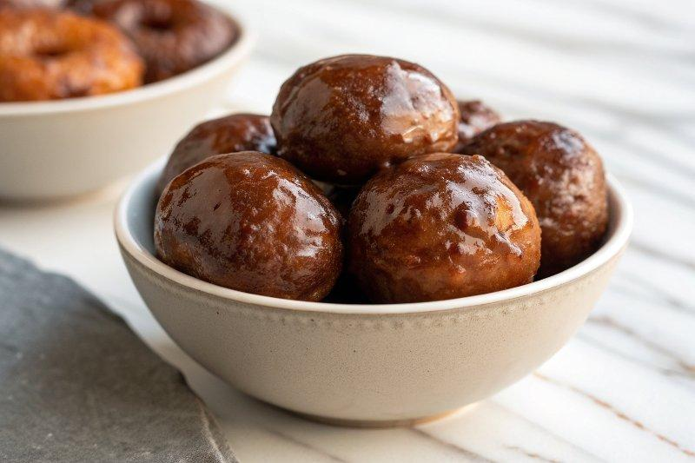

INGREDIENTS  - 2 cup (480ml)s (250 g) white whole wheat flour (spooned & leveled), or half all-purpose + half whole wheat, or all-purpose  - 1 cup (200 g) granulated sugar  - 1/2 cup (41 g) unsweetened cocoa powder  - 1 tsp baking powder  - 1 tsp baking soda  - 1/4 tsp salt  - 2 large eggs, beaten + room temperature*  - 3/4 cup (180 ml) milk, room temperature*  - 1/4 cup (60 g) Greek yogurt (or regular, plain or vanilla, nonfat or low fat)  - 2 tsp pure vanilla extract  - 3 tbsp (43 g) unsalted butter, melted  - 1 and 3/4 cups (225 g) confectioners’ sugar  - 1/4 cup (60 ml) heavy cream (see above for substitution description)  - 1 tsp pure vanilla extract  - 1 tsp lemon juice | PREP  COOK  1. Preheat oven to 350°F (177°C). Spray 24-count mini muffin pan with nonstick spray. Set aside.  2. Make the donuts  3. Sift the flour, sugar, and cocoa powder together in a large bowl. Sifting is important; you want to remove any clumps of cocoa. Mix in the baking powder, baking soda, and salt. Set aside.  4. In a medium bowl, whisk the beaten eggs, milk, yogurt, and vanilla together until completely smooth. Whisk in the melted butter until combined. Slowly fold the wet ingredients into the dry ingredients. Careful not to overmix. Mix the two together only until no flour pockets remain. Over-handling this batter will make your donut holes dense and tough.  5. Spoon batter into the mini muffin tins, only about 3/4 of the way full. Bake for 10 minutes, or until a toothpick inserted in the center comes out clean. Do not overbake them; they burn easily. Allow the donuts to cool for 5 minutes in the pan and then transfer to a wire rack to cool for 5 more minutes before glazing.  6. Make the glaze  7. While the donuts are slightly cooling, make the glaze by sifting the confectioners sugar into a medium bowl. Stir in the milk, vanilla, and lemon juice until smooth and combined. Add more confectioners’ sugar to make it thicker if desired; add more cream to make it thinner if desired. Dunk each slightly warm donut hole into the glaze using a fork or your fingers. Place on a wire rack on top of a large baking sheet to let the glaze drip down. Repeat dunking two to three more times if you want a thick glaze coating. I dunked mine three times. If you run out of glaze to dip each three times, make a bit more.  8. Donut holes taste best served on the same day. This recipe may easily be halved. Store extras in an airtight container at room temperature for up to 3 days.  PLATING

