YOGURT BOWLS (4 WAYS)  COOK TIME: 10 min  SOURCE:  #healthy #quick #breakfast | 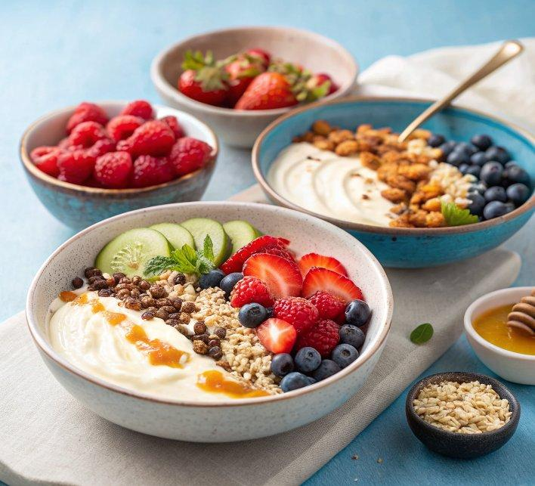

INGREDIENTS  - 1 cup (240ml) plain Greek yogurt (full fat, 2% or 0%)  - 1/4 cup raspberries (strawberries and blueberries)  - 1/4 cup granola  - Drizzle of honey  - 1 cup (240ml) plain Greek yogurt (full fat, 2% or 0%)  - 1/2 banana (sliced)  - 1/4 cup chopped mango  - 2 tbsp unsweetened toasted coconut shreds  - 1 cup (240ml) plain Greek yogurt (full fat, 2% or 0%)  - 1/2 banana (sliced)  - 1 tbsp natural peanut butter or almond butter  - 2 tbsp chocolate chips or cocoa nibs  - 1 cup (240ml) plain Greek yogurt (full fat, 2% or 0%)  - 1 tbsp natural peanut butter or almond butter  - 1 tbsp strawberry chia jam (or your favorite store-bought jam) | PREP  COOK  1. Add yogurt to a bowl and top with toppings. Use a spoon to swirl the toppings in and enjoy!  PLATING

