ROASTED BEET SALAD WITH PEAR AND WALNUTS  COOK TIME: 40 min  SOURCE:  #healthy #quick #seasonal | 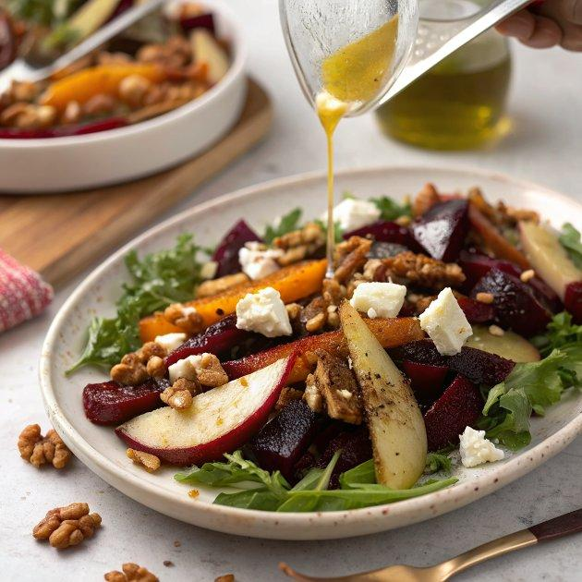

INGREDIENTS  - 3 medium sized beets, any variety (I used a mix of red and golden beets)  - a small drizzle of olive oil, for roasting the beets  - 1 ripe pear, chopped into 1/2-inch (5cm) pieces  - 1/4 cup walnuts, toasted  - 1/4 cup feta cheese, crumbled (or more)  - A few handfuls of salad greens of your choice  - 1/4-1/2 cup cooked quinoa (optional, for a heartier salad)  - Micro sprouts, for garnish (also optional)  - 1-2 tbsp walnut oil  - A drizzle of balsamic vinegar  - A drizzle of honey  - Sea salt and fresh black pepper | PREP  COOK  1. Preheat oven to 350°F (175°C). Roast the beets by drizzling them with a bit of olive oil, some salt and pepper, and wrapping them in foil. Depending on the size and freshness of your beets, they should take from 40 minutes to 1 hour to roast in the oven. Check occasionally, when they are fork-tender they are done. Set them aside to cool. As soon as they’re cool enough to touch, run them under the faucet and slide off the skins with your hands. Chop into roughly ½ inch cubes and set them aside to cool completely. (To save time, I suggest doing this up to one day ahead of time and popping them in the fridge until you’re ready to assemble the salad).  2. Assemble all salad ingredients on a platter. Drizzle with a liberal amount of walnut oil, a bit of balsamic vinegar, a little honey, and some salt and pepper.  PLATING

