NAPA CABBAGE STIR-FRY  COOK TIME: 10 min  SOURCE:  #quick #stir-fry #healthy | 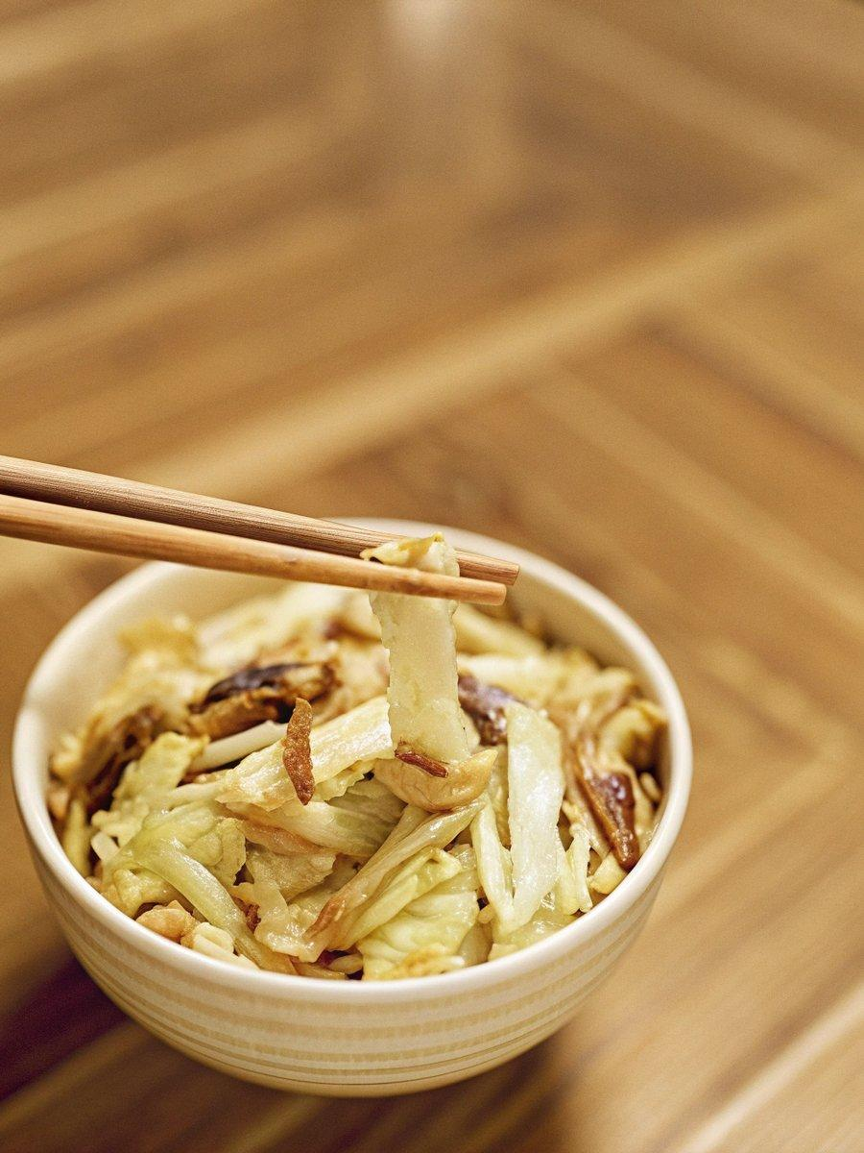

INGREDIENTS  - 1/4 head napa cabbage (1 lb, 454 g, including the core) 1 454  - 3 shiitake mushrooms (1.8 oz, 50 g; or substitute other types of mushrooms or carrots and onion, or skip altogether) 1.8 50  - 3 slices applewood smoked bacon (4 oz, 113 g; bacon adds protein, a savory flavor, and dimensional texture; or substitute shrimp, tofu, or seitan; skip for vegan/vegetarian) 4 113  - 2 tsp neutral oil (for stir-frying, if needed)  - 1/4 tsp Diamond Crystal kosher salt (divided)  - 1/8 tsp freshly ground black pepper  - 2 tsp soy sauce  - Japanese sansho pepper (optional) | PREP  COOK  1. Gather all the ingredients.  2. To Prepare the Ingredients  3. Cut ¼ head napa cabbage crosswise into pieces 2-inch (5cm)es (5 cm) long, and then cut the tough, thick pieces in half or thirds lengthwise.  4. Cut off and discard the stems of 3 shiitake mushrooms. Thinly slice the shiitake caps.  5. Cut 3 slices applewood smoked bacon into strips ½ inch (1.3 cm) wide.  6. To Stir-Fry  7. Heat an ungreased large frying pan on medium-high heat. Once it’s hot, add the bacon and stir-fry.  8. Cook until the bacon fat has rendered. I added 2 tsp neutral oil to coat the bottom of my well-seasoned carbon steel pan as there wasn‘t enough rendered fat.  9. Add the tough, thick pieces of napa cabbage. Sprinkle with half of the ¼ tsp Diamond Crystal kosher salt.  1  0. Stir to mix and cook, covered, on medium-low heat for 2 minutes.  1  1. Open the lid and stir. Add the shiitake and the tender, leafy pieces of the napa cabbage.  1  2. Sprinkle with the rest of the salt and stir to mix.  1  3. Cook, covered, for 3–4 minutes. Open the lid and see if the tough napa cabbage pieces are cooked through.  1  4. If not, cover and continue to cook for 1–2 minutes. Stir to make sure the napa cabbage is crisp-tender and evenly cooked.  1  5. Season with ⅛ tsp freshly ground black pepper and 2 tsp soy sauce. Stir to mix.  1  6. Transfer the Napa Cabbage Stir-Fry to a large plate. I sprinkle my stir-fry with freshly ground Japanese sansho pepper (optional) to enjoy.  1  7. To Store  1  8. You can keep the leftovers in an airtight container and keep them for 3 days in the refrigerator or for up to a month in the freezer.  PLATING

