HOMEMADE SOURDOUGH STARTER  COOK TIME: 336h  SOURCE:  #homemade #fermentation #artisan | 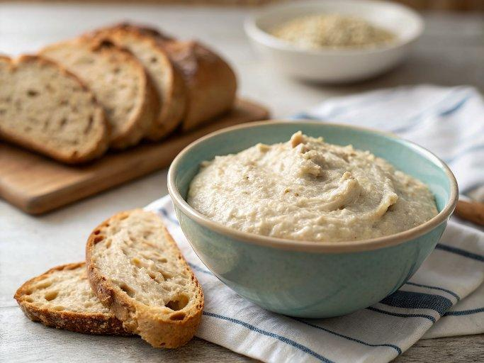

INGREDIENTS  - Organic whole-wheat flour or rye flour  - Bread flour  - Bottled water | PREP  COOK  1. Day 1:  2. In a perfectly clean bowl, combine a scant cup (120 grams) organic whole wheat flour and 1/2 cup (120 grams) bottled water. With a clean spoon, stir until a stiff dough forms. If the dough is extremely dry, add very small amounts of water until moistened. Scrape the dough into the 4-cup container. You should have about 1 cup (240 grams). Cover tightly in plastic wrap and place in a cool area for 48 hours. If you don’t have a cool area, let it sit for only 24 hours and feed as described for Day  3.  3. Day 2:  4. There will be no visible changes.  5. Day 3:  6. The consistency will now resemble a thick pancake batter and there may be a few bubbles. With a clean spoon, remove and throw away about half the starter, about 1/2 cup (120 grams).  7. Stir in a scant 1/2 cup (60 grams) bread flour and 1/4 cup (60 grams) bottled water. Cover tightly with plastic wrap and leave at room temperature for 24 hours. After 12 hours the starter may have increased quite a bit and have lots of bubbles. Don’t be concerned if it deflates and falls back down.  8. Day 4:  9. With a clean spoon, again remove and throw out about half of the starter, 1/2 cup (120 grams). Stir in a scant 1/2 cup (60 grams) bread flour and 1/4 cup (60 grams) bottled water. Cover with plastic wrap, but not tightly, as the gases forming will need to escape. Leave at room temperature for 24 hours.  1  0. Day 5:  1  1. If the starter is active, it will have increased in volume to at least 3 cups (720ml), even  4. It will dome and start to recede. If this hasn’t happened yet, repeat Day 4 steps until it reaches this stage.  1  2. With a clean spoon, again remove and throw out half the starter (1/2 cup or 120 grams).  1  3. Stir in 1/2 cup (60 grams) bread flour and 1/4 cup (60 grams) bottled water.  1  4. You will now have 1 cup (60 grams) active starter. Cover with plastic wrap and let sit at warm room temeperature for about 4 hours, until it has almost doubled. If you want to bake bread, you can now expand it by feeding it with flour and water. If you want to wait, you can refrigerate it overnight and start expanding it the next day. If you don’t plan to use it for several days, feed it again to double it, let it sit for 1 hour, then refrigerate it.  1  5. The starter will mature over the next few weeks, increasing in strength and flavor. For the first 2 weeks, store at least 1 cup (240 grams) of it and feed it at least three times a week. After 2 weeks of regular feeding at least 3 times a week the culture is mature and bread made from it will be more mellow and complex. Now you can switch to once-a-week feeding if you only make bread once a week.  PLATING

