CHINESE-STYLE AVOCADO TOAST  COOK TIME: 5 min  SOURCE:  #quick #healthy #comfort-food | 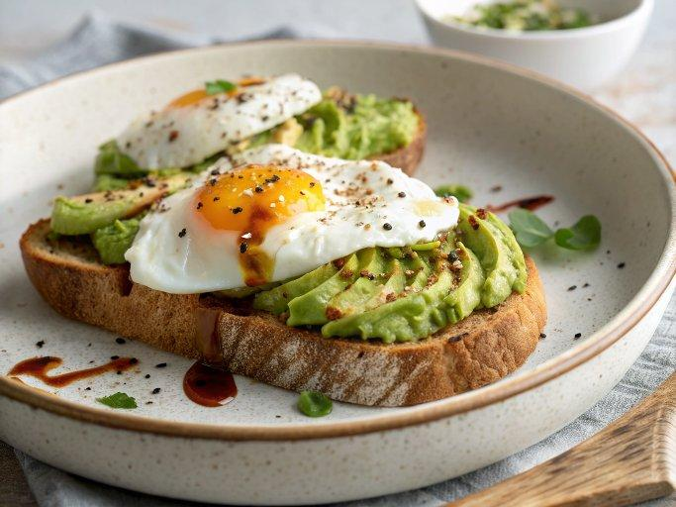

INGREDIENTS  - 1 tbsp vegetable oil  - 4 Pete & Gerry’s Pasture-Raised Eggs  - 4 slices bread , toasted  - 2 avocados , sliced  - 2 tsp soy sauce  - 4 tsp chili oil  - Sliced green onion for garnish (Optional)  - Toasted sesame seeds for garnish (Optional) | PREP  COOK  1. Heat oil in a skillet over medium heat until hot. Add the eggs. Cook to the degree you prefer, sunny side up, over easy, or well done. Transfer to a plate.  2. Spread the avocado slices over each piece of toast. Top with the fried egg.  3. Drizzle each toast with 1/2 teaspoon of soy sauce and 1 teaspoon of chili oil. Garnish with sliced green onion and / or sesame seeds, if using. Enjoy!  PLATING

