STRAWBERRY MUFFINS  COOK TIME: 18 min  SOURCE:  #baking #sweet #fruit | 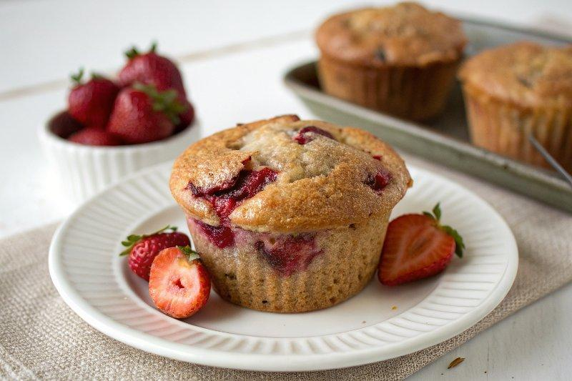

INGREDIENTS  - 3 cups (720ml) all-purpose flour (360 g)  - 1 tbsp baking powder  - 1/2 tsp salt  - 1 cup (240ml) unsalted butter (softened (226 g)  - 1 1/2 cups granulated sugar (300 g)  - 2 large eggs (room temperature)  - 1 tsp vanilla extract  - 1 cup (240ml) milk (240 mL)  - 1 3/4 cups diced fresh strawberries (328 g) | PREP  COOK  1. Preheat the oven to 375°F (190°C). Line a 12-cup muffin pan with paper liners.  2. In a medium mixing bowl, whisk together the flour, baking powder, and salt.  3. In a large mixing bowl or the bowl of a stand mixer fitted with the paddle attachment, beat the butter and sugar together on medium-high until the light and fluffy, about 5 minutes.  4. Reduce the speed to medium. Add the eggs one at a time, beating until well combined before adding the next. Beat in the vanilla.  5. Reduce the speed to low. Add the flour mixture to butter mixture in 3 additions, alternating with milk. Once all is added, mix just until a few streaks of flour remain. Using a rubber spatula, fold in the strawberries.  6. Divide the batter evenly among the paper liners (they will be almost full). If desired, top each muffin with additional diced strawberries and sprinkle with sugar.  7. Bake for 18 to 20 minutes or until the tops are golden brown and a toothpick inserted into the center comes out clean. Let cool for a few minutes in the pan, then remove and finish cooling on a wire rack. Muffins can be stored in an airtight container for up to 3 days or frozen or up to 1 month.  PLATING

