SWEET & SPICY SRIRACHA TOFU  COOK TIME: 20 min  SOURCE:  #quick #spicy #tofu | 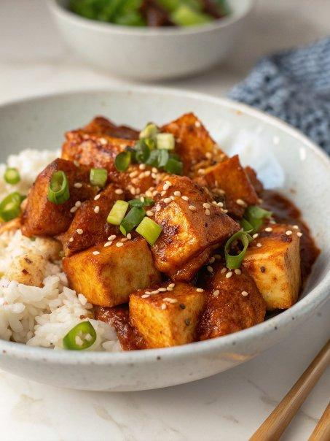

INGREDIENTS  - 1 block (350 g) extra-firm tofu (drained and pressed (see notes), cubed)  - 1/3 cup cornstarch  - 2 tbsp oil for frying  - cooked rice for serving  - 1 cup (240ml) water  - 1/4 cup soy sauce  - 1/4 cup white sugar  - 1 - 3 tbsp Sriracha ((depending on your spice preference))  - 2 tbsp agave  - 3 cloves garlic, (minced)  - 2 tbsp cornstarch  - 2 tbsp water | PREP  COOK  1. To make the tofu: add the tofu to a medium bowl with the cornstarch. Toss well to coat, and shake off excess.  2. Heat the oil in a pan and fry the tofu cubes until all sides are browned. About 4 minutes each side. Drain tofu on paper towel to get rid of excess oil.  3. To make the Sriracha sauce: in a small saucepan, 1 cup (240ml) water, soy sauce, sugar, sriracha, agave, and garlic, then bring to a boil. In a small bowl or glass, mix the cornstarch and 2 tablespoons water together. Pour the cornstarch mixture into the sauce and whisk well. Continue to cook another minute or two until the sauce thickens.  4. Toss the sauce with the tofu and serve over a bed of rice.  PLATING

