GRILLED PEACH AND WATERMELON BURRATA SALAD  COOK TIME: 10 min  SOURCE:  #grilled #fresh #summer | 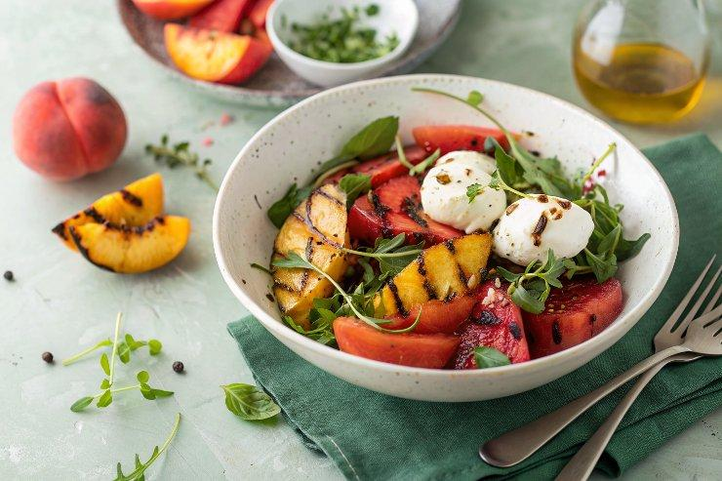

INGREDIENTS  - 4 peaches (cut into 1⁄2-inch-thick wedges)  - Olive oil spray (I like my Misto or Bertolli)  - 4 small balls burrata cheese (1 lb total)  - 4 cups (960ml) cubed seedless watermelon  - 1/2 cup loosely packed watercress  - 2 tbsp balsamic glaze (I like DeLallo) | PREP  COOK  1. Preheat a grill pan over medium-high heat (or preheat a grill to medium-high).  2. Spray the peaches with oil, then grill them cut sides down, just long enough to make marks, about 2 minutes per side.  3. To serve, place a ball of burrata in the center of each of 4 plates and arrange the grilled peaches, watermelon cubes, and watercress around it.  4. Drizzle everything with the balsamic glaze.  PLATING

