SPIRALIZED SUMMER ROLL BOWLS WITH HOISIN PEANUT SAUCE  COOK TIME: 10 min  SOURCE:  #quick #healthy #seafood | 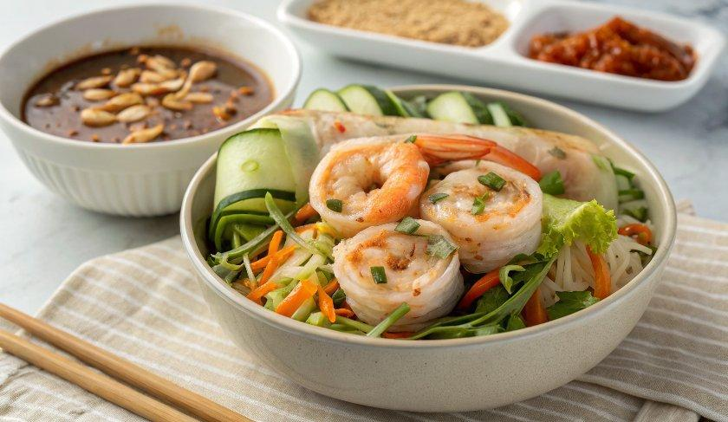

INGREDIENTS  - 2 tbsp creamy peanut butter  - 2 tsp reduced-sodium soy sauce*  - 1 tbsp hoisin sauce*  - 1 tsp sriracha  - 1/2 tsp grated ginger  - 4 tbsp warm water (to thin)  -  - 24 jumbo peeled and cooked shrimp  - 2 large English cucumbers  - 1 thick carrot (I used 8 oz)  - 1 cup (240ml) shredded red cabbage  - 2 tbsp cilantro leaves  - 12 basil leaves  - 12 mint leaves  - 2 tbsp chopped peanuts | PREP  COOK  1. Mix all the sauce ingredients in a small bowl and refrigerate until ready to use.  2. Spiralize the cucumbers and carrots, then cut into 6-inch (15cm) lengths. Divide the cucumbers, carrot, red cabbage between 4 bowls. Top each with 6 shrimp, 2 tbsp peanut dressing, fresh herbs and chopped peanuts.  PLATING

