CHINESE-STYLE SPICY BEEF SALAD  COOK TIME: 5 min  SOURCE:  #spicy #salad #beef | 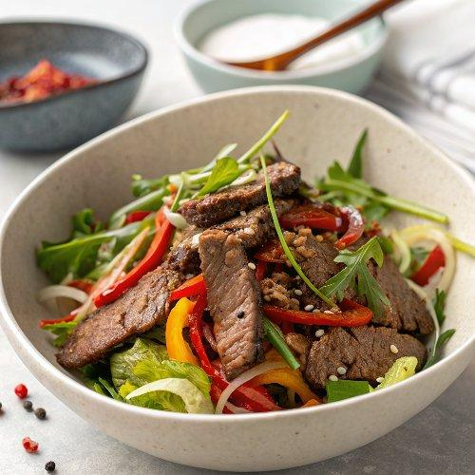

INGREDIENTS  - 12 oz flank steak (partially frozen; can also use chuck)  - 2 tbsp water  - 2 tsp cornstarch  - 1 tsp vegetable oil  - 1 tsp Shaoxing wine  - 1/4 tsp baking soda  - 1/2 tsp salt  - 1 tbsp garlic (minced)  - 1 Thai bird chili (minced)  - 1/2 tsp sugar  - 1 tbsp toasted sesame seeds  - 2 tsp Sichuan chili flakes  - 2 tbsp vegetable oil  - 1 tsp rice vinegar  - 1 tsp oyster sauce  - 1 tsp light soy sauce  - 1/2 tsp dark soy sauce  - 1/4 cup cilantro (leaves and stems, roughly chopped) | PREP  COOK  1. Very thinly slice flank steak against the grain (it should be partially frozen to make this easier), and add it to a medium bowl. Add the water, cornstarch, vegetable oil, Shaoxing wine, baking soda, and salt. Mix well, and marinate for 30 minutes.  2. Meanwhile, bring a medium pot of water to a boil. Add the beef, and blanch for 45 seconds to 1 minute, just until it turns mostly opaque (it’s ok if it’s still a little pale pink in spots). Drain well and transfer the beef to a mixing bowl.  3. Add the garlic, chili, sugar, sesame seeds, and Sichuan chili flakes to the beef in little piles next to each other. Heat 2 tablespoons of vegetable oil in a small pan, and pour over the garlic, chili, and sesame seeds.  4. Add the vinegar, oyster sauce, light soy sauce, dark soy sauce, and cilantro. Toss and serve.  PLATING

