PICO DE GALLO  COOK TIME: 20 min  SOURCE:  #fresh #salsa #quick | 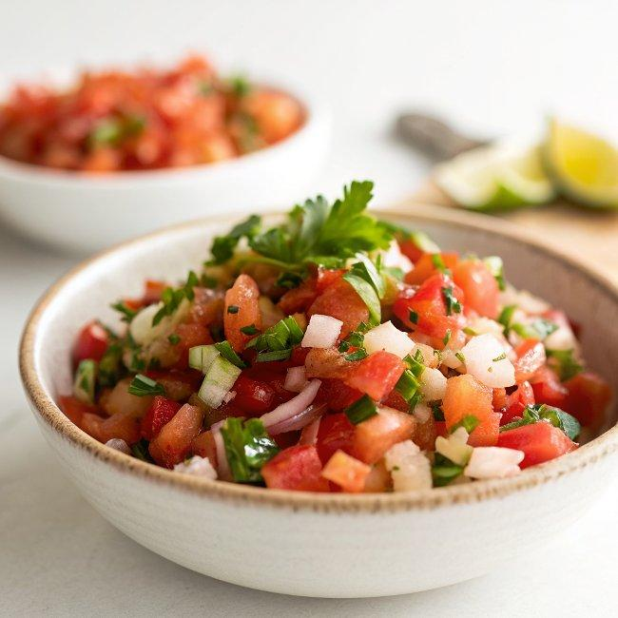

INGREDIENTS  - 2 medium ripe tomatoes (about 1 lb/454 g), cored and chopped into 1/4-inch (6-mm) pieces ()  - 1/4 cup finely chopped white or red onion, from 1 onion  - 1/4 cup chopped fresh cilantro  - 1 jalapeño pepper, stemmed, seeded, and minced (see pro tip)  - 1 tbsp lime juice, from 1 lime  - 1 clove garlic, minced  - Heaping 1/4 tsp salt | PREP  COOK  1. In a medium bowl, combine the tomatoes, onion, cilantro, jalapeño, lime juice, garlic, and salt. Taste and adjust seasoning with lime juice and salt, adding some of the reserved seeds for a spicier salsa, if desired. Serve immediately or cover and refrigerate for up to 1 hour before serving. Store leftover salsa in an airtight container in the refrigerator for up to one day.  PLATING

