DALGONA COFFEE (KOREAN WHIPPED COFFEE)  COOK TIME: 5 min  SOURCE:  #quick #whipped #coffee | 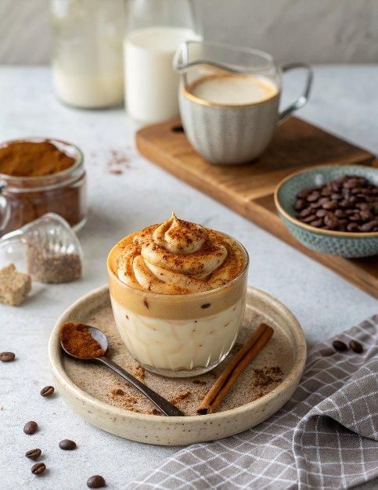

INGREDIENTS  - 1 Tbsp instant coffee (I used Moccona vanilla praline and it’s super tasty!)  - 1 Tbsp sugar  - 1 Tbsp hot water  - 3/4 cups milk (~ 1 cup, chilled or heated)  - ice cubes (optional) | PREP  COOK  1. Combine instant coffee, sugar and hot water in a mixing bowl. Mix them well. Then using a handheld mixer (stand mixer or milk frother) whisk it on high speed until the coffee mixture forms a stiff peak (2-4 mins). If you don’t have any of these tools, you can whisk it manually by hand. It still works! Just whisk it about 400 times.  2. Add the ice cubes in a mug then pour over the milk. Scoop out the whipped coffee on top of the milk. Serve.  PLATING

