SERIOUSLY DELICIOUS DETOX SALAD  COOK TIME: 15 min  SOURCE:  #healthy #detox #fresh | 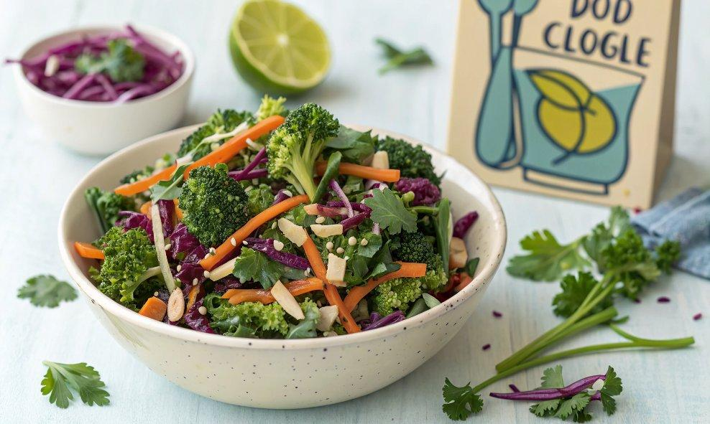

INGREDIENTS  - 3 cups (720ml) finely-chopped* kale leaves  - 2 cups (480ml) finely-chopped broccoli florets  - 2 cups (480ml) finely-chopped red cabbage  - 1 cup (240ml) matchstick (shredded) carrots  - 1 cup (240ml) roughly-chopped fresh cilantro leaves  - 1/2 cup toasted slivered almonds  - 1/3 cup thinly-sliced green onions  - 1 avocado, peeled pitted and diced  - 1 batch Carrot Ginger Dressing (see below)  - 1 large carrot, peeled and roughly-chopped  - 1/4 cup rice wine vinegar  - 2 tbsp avocado oil or olive oil (or any mild-flavored cooking oil)  - 1 tbsp finely-chopped fresh ginger  - 1 tbsp honey (or your desired sweetener)  - 1 tbsp white (shiro) miso  - 1/2 tsp toasted sesame oil  - Kosher salt and black pepper, to taste | PREP  COOK  1. To Make The Salad:  2. Add all ingredients together in a large bowl, and toss to combine. Serve immediately. (Or if you are not going to serve the entire salad in one setting, the salad can be mixed without the dressing and refrigerated in a sealed container for up to 2 days with the dressing refrigerated separately in another sealed container.)  3. To Make The Carrot-Ginger Dressing:  4. Add all ingredients to a blender or food processor, and pulse until completely smooth. Season to taste with salt and pepper, and/or add extra honey if you’d like a sweeter dressing. Serve immediately or refrigerate in a sealed container for up to 1 week.  PLATING

