LAMB & RED WINE STEW  COOK TIME: 2h 30m  SOURCE:  #comfort-food #hearty #slow-cooked | 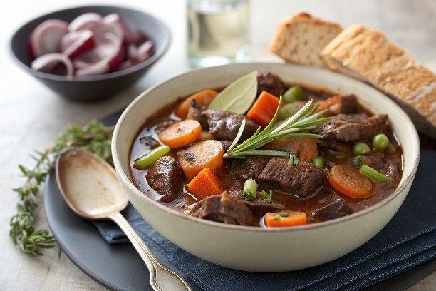

INGREDIENTS  - 2 sticks of celery  - 2 onions  - 2 carrots  - 1 bay leaf  - 3 sprigs of fresh rosemary  - olive oil  - 500 g stewing lamb  - 1 heaped tbsp plain flour  - 500ml (2.1 cups) red wine  - 1 x 400 g tin of chopped tomatoes  - 250 g self-raising flour  - 125 g cold unsalted butter  - 1 kg potatoes  - 1 splash of milk  - 1 large knob of unsalted butter  - 1 sprig of fresh rosemary  - olive oil | PREP  COOK  1. Preheat the oven to 180ºC/350ºF/gas  4.  2. Trim the ends off the celery and roughly chop the sticks. Peel and roughly chop the onions. Peel the carrots, slice them lengthways and roughly chop.  3. Put a casserole pan on a medium heat. Put all the vegetables, bay and rosemary into the pan with 2 tablespoons of olive oil and fry for 10 minutes.  4. Dice the lamb into roughly 2cm (1-inch) cubes (if it isn’t already), then add to the pan with the flour.  5. Pour in the wine and tomatoes. Give it a good stir, then season with a pinch of sea salt and a few grinds of black pepper.  6. Bring to the boil, put the lid on and cook in the oven for 2 hours 30 minutes, or until the meat is tender and delicious, removing the lid for the final 30 minutes and adding a splash of water if it looks too dry. (You could also simmer over a medium-low heat on your hob if you prefer.)  7. Remove the bay leaf and rosemary stalks, season to taste, then serve. Or finish it off with one of these toppings…  PLATING

