MEDITERRANEAN SAVORY BREAKFAST BOWLS  COOK TIME: 5 min  SOURCE:  #quick #healthy #comfort-food | 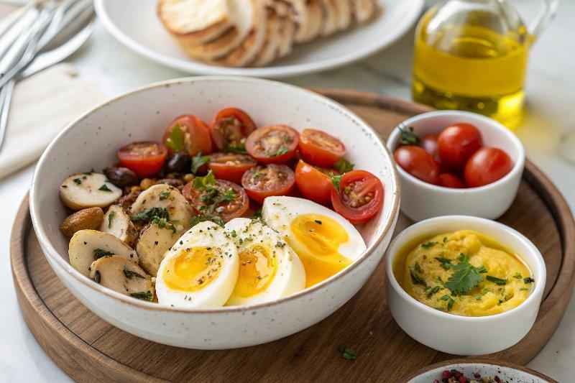

INGREDIENTS  - 4 eggs, (cooked to your liking (I am using soft boiled eggs)  - 8 oz white button mushrooms (halved)  - extra virgin olive oil  - Kosher salt  - 2 cups (480ml) cherry tomatoes  - 2 cups (480ml) baby spinach (packed)  - 1 to 2 garlic cloves (minced)  - 1 1/2 cups hummus (homemade ahead or quality store-bought)  - seasoning of your choice  - olives (optional) | PREP  COOK  1. Cook the eggs to your liking. I went with soft boiled eggs, but scrambled, sunny-side up or any way you like them will work. (Boiled eggs can be cooked in advance and refrigerated for later use).  2. Heat 2 tablespoons olive oil in a large skillet. Add the mushrooms. Season with salt and cook on both sides until browned (about 7 minutes)  3. Add the cherry tomatoes, spinach, garlic. Season with another pinch of salt. Cook briefly, 2 to 3 minutes, till warmed through and the spinach wilts.  4. Assemble the bowls. Divide the mushroom, spinach and tomato mixture among 4 bowls. Add the eggs and hummus next. Drizzle a bit of extra virgin olive oil over the hummus, if you like.  5. Add seasonings of your choice (I used a little Aleppo Pepper and za’atar, about 1 teaspoon each).  PLATING

