GROUND BEEF TACO RECIPE  COOK TIME: 15 min  SOURCE:  #quick #comfort-food #taco | 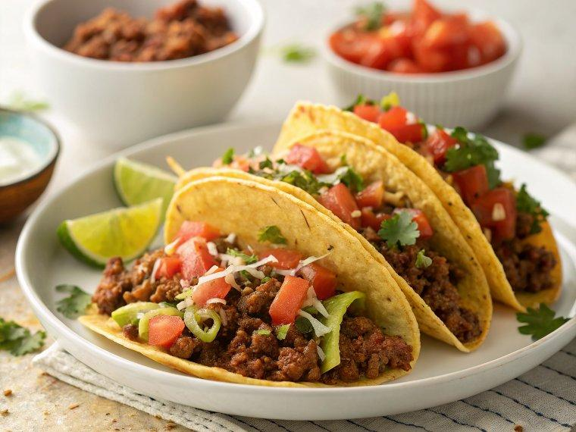

INGREDIENTS  - 2 lbs ground beef chuck (10% to 20% fat)  - 20 oz Rotel Tomatoes with Green Chilis (Two 10 oz cans with their juice)  - 1 tsp chili powder (plus more for serving)  - 1 tsp kosher salt (or to taste)  - 20 yellow corn tortillas (small) or Hard Taco Shells)  - 1/2 iceberg lettuce (shredded)  - 2/3 cup sour cream (for topping)  - 2 limes (cut into wedges)  - 1/4 bunch Cilantro sprigs (to serve) | PREP  COOK  1. Heat a large non-stick skillet over med-high heat. Add 2 lbs ground beef and cook, stirring occasionally until cooked through (5 minutes). Use a spoon to skim off and discard most of the excess fat, leaving about 2-3 Tbsp in the pan.  2. Add 2 cans of tomatoes, 1 tsp chili powder and 1 tsp salt. Continue to cook until beef is fully cooked and sauce slightly reduced and most of the tomato liquid has evaporated (7 to 10 minutes).  3. Before serving, on a dry large non-stick pan over medium/high heat, toast both sides of tortillas just until hot and barely starting to turn golden (15-30 seconds per side). Remove to a plate and cover loosely with foil to keep warm.  4. To serve, place a heaping spoonful of beef over each tortilla, top with lettuce, mango salsa, sprigs of cilantro, sour cream and a sprinkle of chili powder if desired. Squeeze fresh lime juice just before eating.  PLATING

