LAMB KOFTA  COOK TIME: 40 min  SOURCE:  #grilled #comfort-food #high-protein | 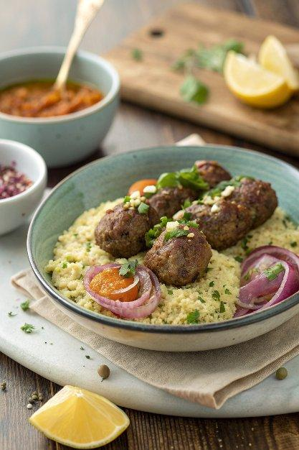

INGREDIENTS  - 100 g wholewheat couscous  - 1 lemon  - 25 g dried apricots  - 25 g shelled unsalted pistachios  - 250 g higher-welfare lamb mince  - 1 tsp ras el hanout  - olive oil  - 1/2 a small red onion  - red wine vinegar  - 1/2 a bunch of flat-leaf parsley (15 g)  - 1/2 a bunch of mint (15 g)  - extra virgin olive oil  - 1 x 400 g tin of chickpeas  - 1 tbsp harissa paste  - 4 tbsp Greek yoghurt | PREP  COOK  1. Put the couscous into a bowl, finely grate over the lemon zest, just cover with boiling kettle water, cover, and put aside.  2. Finely chop the apricots and pistachios and put into another bowl with the lamb, ras el hanout and a good pinch of sea salt and black pepper. Fluff up the couscous with a fork, add one third to the lamb mix, then scrunch together with clean hands.  3. Divide the mixture into 8 equal-sized pieces, then shape into koftas with your fingertips, leaving dents in the surface to increase the gnarly bits as they cook. Place in the air-fryer drawer, spritz with olive oil and cook for 20 minutes at 180ºC, or until sizzling, shaking halfway.  4. Meanwhile, peel and very finely slice the red onion, then scrunch with a pinch of salt and 2 tablespoons of red wine vinegar and leave to quickly pickle.  5. Finely chop the herb leaves and add to the remaining couscous with a good squeeze of lemon juice and 1 tablespoon of extra virgin olive oil. Drain and add the chickpeas, toss well, season to perfection and divide between plates.  6. Sit the kofta on top, then ripple the harissa through the yoghurt and spoon on the side. Sprinkle over the pickled red onions, and serve with lemon wedges.  PLATING

