EASY BRUSCHETTA CHICKEN RECIPE  COOK TIME: 15 min  SOURCE:  #quick #comfort-food #chicken | 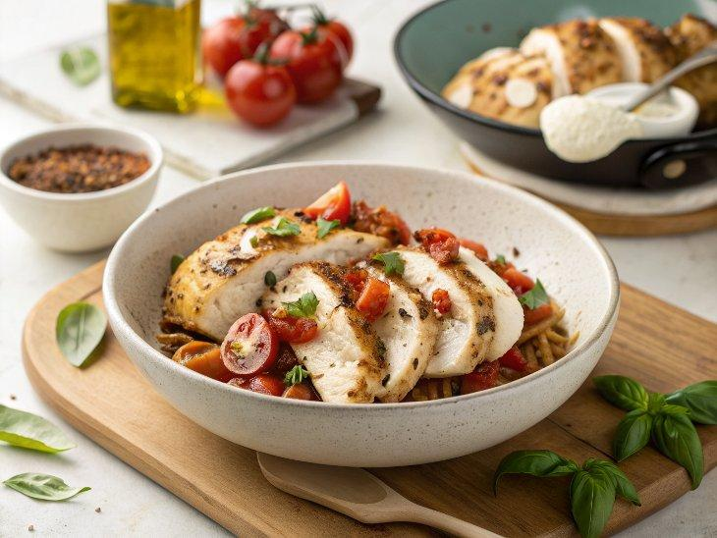

INGREDIENTS  - 4 large chicken breasts (2 lbs)  - 2 Tbsp olive oil  - 1 tsp salt  - 2 tsp Italian seasoning  - 1/2 tsp black pepper  - 2 garlic cloves (minced)  - 4 slices mozzarella cheese  - 1 Tbsp olive oil (for sautéing)  - 12 oz Roma tomatoes (3/4 lb, diced)  - 2 1/2 Tbsps basil leaves (chopped)  - 3 garlic cloves  - 1/2 Tbsp balsamic vinegar  - 1 Tbsp extra virgin olive oil  - 1/4 tsp salt  - 1/8 tsp black pepper  - 4 Tbsp balsamic glaze | PREP  COOK  1. Prepare Bruschetta:  2. In a bowl, add the diced tomatoes, chopped basil leaves, minced garlic, balsamic vinegar, oil, salt, and pepper and mix until well combined, set aside.  3. Prepare Chicken:  4. Beat the chicken until it's even in thickness. In a large bowl add the 2 Tbsp oil, salt, Italian seasoning, black pepper and minced garlic. Add chicken and stir to coat then cover and marinate for 30 minutes.  5. In a large skillet, over medium heat, heat 1 Tbsp olive oil. Once hot, add the chicken to the skillet and saute for 3-5 minutes per side, or until the internal temperature of the chicken reaches 165ºF on a food thermometer.  6. Once the chicken is cooked, reduce the heat to low and top each chicken with a slice of cheese. Cover the skillet with a lid and cook until cheese melts.  7. Remove the chicken from heat. Top each chicken breast with the Bruschetta and drizzle with balsamic glaze before serving.  PLATING

