ONE POT CHICKEN ENCHILADA RICE CASSEROLE  COOK TIME: 25 min  SOURCE:  #one-pot #comfort-food #chicken | 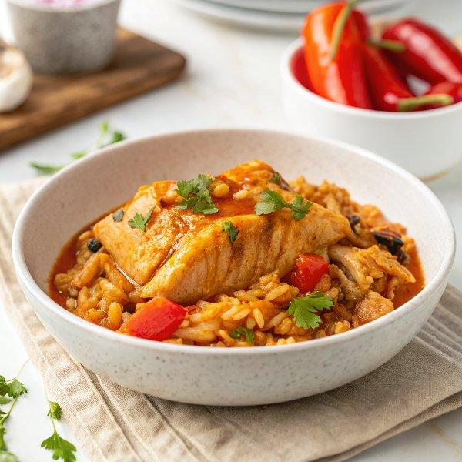

INGREDIENTS  - 1 tbsp olive oil  - 400 g (13 oz) chicken breast, about 1/3"/1cm (0-inch) thick, sliced horizontally into thin steaks (Note 1)  - 1 small onion, diced  - 3 cloves garlic, crushed  - 1 red bell pepper/capsicum, diced  - 680 g (24 oz) tomato passata or crushed canned tomatoes* (Note 2)  - 3 cups (720ml) chicken broth or water (750 ml)  - 1 1/2 cups frozen corn (250 g)  - 1/2 tsp cayenne pepper* (spicy - adjust to taste)  - 1 tbsp dried oregano*  - 2 tsp cumin*  - 1 1/2 tsp coriander*  - 2 tsp onion powder*  - 1 tbsp brown sugar*  - Salt and pepper  - 1 1/2 cups (270 g) white rice (short, medium or long grain (, uncooked (Note 4)  - 1 - 1 1/2 cups grated cheese (about 125 - 150 g)  - Chopped cilantro/coriander (optional) | PREP  COOK  1. Heat olive oil over medium high heat in large skillet.  2. Add chicken and cook each side for 2 minutes or until cooked, then remove onto a plate.  3. Add extra oil if the skillet is looking dry. Add onion and garlic, cook for 1 1/2 minutes until starting to soften.  4. Add bell peppers and cook for a further 2 minutes.  5. Add remaining ingredients except rice and cheese. Bring to simmer, then add rice.  6. Stir, cover with a lid and turn down heat to medium low. Cover and cook until rice is cooked but not mushy and most of the liquid is absorbed - about 15 to 18 minutes. (Note 3). Do not stir while it cooks.  7. Meanwhile, shred or roughly chop chicken.  8. When rice is cooked, quickly stir chicken through, sprinkle with cheese then pop under broil / grill until golden and bubbly.  9. Serve, garnished with fresh cilantro/coriander if desired.  PLATING

