CHICKEN MILANESE & SPAGHETTI ARRABBIATA  COOK TIME: 45 min  SOURCE:  #comfort-food #quick #pasta | 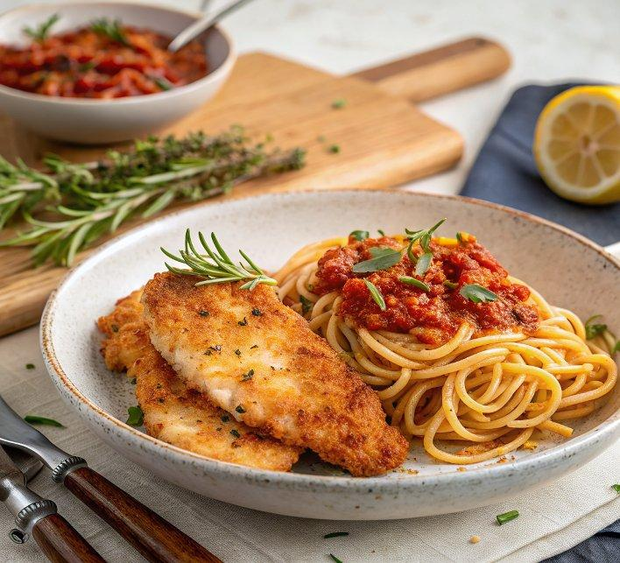

INGREDIENTS  - extra virgin olive oil  - 2 cloves of garlic  - 2 sprigs of rosemary  - 1 lemon  - 1 dried chilli  - 2 fresh red chillies  - 2 anchovies in oil, from sustainable sources  - optional: 50 ml gin  - 1 x 680 g jar of passata  - 1 heaped tbsp crème fraîche  - 150 g spaghetti  - 100 g plain flour  - 1 large free-range egg  - 60 g white breadcrumbs  - 2 free-range chicken supremes (wing tip and bone in) or chicken breasts, skin off  - vegetable oil, for frying  - 2 sprigs of lemon thyme or thyme, plus an extra sprig for frying  - 20 g unsalted butter  - Spenwood or pecorino, or your favourite hard cheese, to serve | PREP  COOK  1. For the arrabbiata sauce, drizzle 2 tablespoons of extra virgin olive oil in a shallow casserole pan over a medium heat. Peel, finely slice and add the garlic, along with the rosemary sprig tips (save the rest for tasty cooking another day). Use a speed-peeler to strip off little flecks of lemon peel into the pan. Crumble in the dried chilli, then halve and deseed the fresh chillies, adding the whole halves to the pan. Stir in the anchovies with a drizzle of their oil from the tin and cook for 5 minutes, or until the anchovies have melted and the garlic is starting to soften, stirring regularly. Add the gin and very carefully flame, if you like (stand well back and watch your eyebrows!).  2. Add the passata to one side of the pan (this will push the oil to the other side of the pan and amplify its flavour). Let it bubble away for a minute, then add a pinch of black pepper and stir well to combine. Bring to a simmer, reduce the heat to medium-low and cook for another 10 to 15 minutes, or until the sauce is reduced, glossy and thick, then ripple through the crème fraîche and remove from the heat.  3. Meanwhile, tip the flour into a large bowl, crack and beat the egg in a second bowl with a pinch of pepper, and place the breadcrumbs in a third.  4. Cover the chicken with a sheet of greaseproof paper, bash with a rolling pin to tenderise and flatten to 1cm (0-inch) thick, then season with a pinch of sea salt and pepper (if using chicken supremes, I like to pick up the wing and run a sharp knife around the bone, pull the wing meat back on itself to create a chicken lollipop).  5. Coat the chicken in the flour, then the egg and finally in the breadcrumbs, until thoroughly coated, shaking off any excess as you go, then use clean hands to press the breadcrumbs into the chicken.  6. Pour 1cm (0-inch) of vegetable oil into a large frying pan on a medium-high heat with a small sprig of lemon thyme or thyme (or rosemary) – it’ll impart flavour and sizzle when the oil is hot enough for frying. Cook the chicken for 8 to 10 minutes, or until golden and cooked through, turning halfway, then remove to kitchen paper to drain. When the time’s almost up, add the butter to the pan and allow it to melt, then strip in the lemon thyme and spoon the flavoured butter all over the chicken.  7. Cook the spaghetti in a pan of boiling salted water according to the packet instructions, then use tongs to drag it directly into the pan of arrabbiata sauce, taking a little pasta water with it. Toss together, adding another splash of cooking water to loosen, if needed.  8. Divide the spaghetti between serving plates, then slice up and arrange the chicken on top. Finely grate over the cheese and serve with lemon wedges, for squeezing over. Great with a green seasonal salad.  PLATING

