HIGH PROTEIN COTTAGE CHEESE MAC AND CHEESE  COOK TIME: 20 min  SOURCE:  #comfort-food #quick #high-protein | 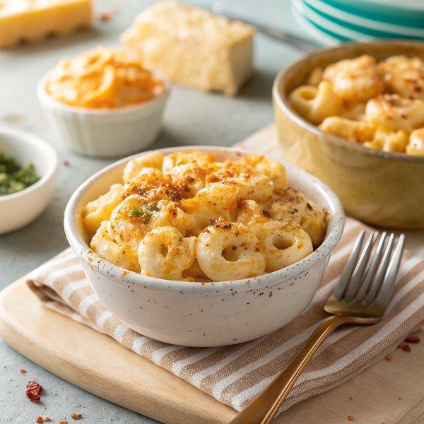

INGREDIENTS  - 8 oz elbow macaroni noodles  - 1 cup (240ml) full fat cottage cheese  - 1 cup (240ml) whole milk  - 1 cup (240ml) freshly grated cheddar cheese  - 1 tbsp arrowroot powder or cornstarch  - 1/2 tsp garlic powder  - 1/2 tsp onion powder  - 1/4 tsp paprika  - 1/4 tsp black pepper  - Salt to taste | PREP  COOK  1. Cook pasta  2. Cook the pasta according to package directions. Drain and set aside.  3. Blend sauce  4. While the pasta is cooking, add the cottage cheese, milk, cheddar cheese, arrowroot powder, garlic powder, paprika and black pepper to a blender. Blend until smooth.  5. Heat sauce  6. In a separate large skillet or saucepan pour the cheese sauce into it and heat over medium-low for about 8-10 minutes, whisking occasionally until the cheese sauce is heated and thickens slightly.  7. Combine  8. Add the cooked pasta to the cheese sauce and stir to fully coat the pasta. The sauce might seem thin at first but it’ll start to thicken as it sits for a few minutes. Taste and add any additional seasonings if desired. Enjoy!  PLATING

