KOTHAMALLI THOVAYAL RECIPE (DRY CORIANDER LEAVES CHUTNEY)  COOK TIME: 10 min  SOURCE:  #quick #spicy #condiment | 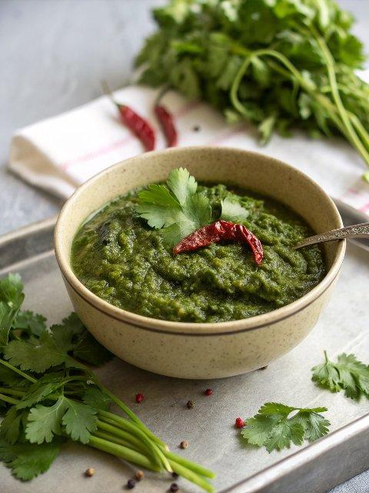

INGREDIENTS  - 15 sprig Coriander (Dhania) Leaves  - 1/4 cup White Urad Dal (Split)  - 5 Dry Red Chillies  - Asafoetida (hing) A pinch  - 20 g Tamarind  - 2 tbsp Fresh coconut grated (optional)  - 1/2 tsp Oil  - Salt to taste | PREP  COOK  1. To begin making Kothamalli Thovayal Recipe, heat oil in a pan and roast the split urad dal till golden brown and keep aside.  2. In the same pan, add the died red chillies and roast. Keep this aside.  3. Add the roughly chopped coriander leaves to the pan and saute until it just get wilted and switch off the flame.  4. Once cool, grind all the roasted ingredients together along with salt, tamarind, asafoetida and coconut to a coarse consistency.  5. Serve the Kothamalli Thovayal Recipe along with Steamed Rice,Tomato Rasam and Elai Vadam for a simple weeknight dinner.  PLATING

