VALENTINE COOKIES  COOK TIME: 12 min  SOURCE:  #sweet #baking #holiday | 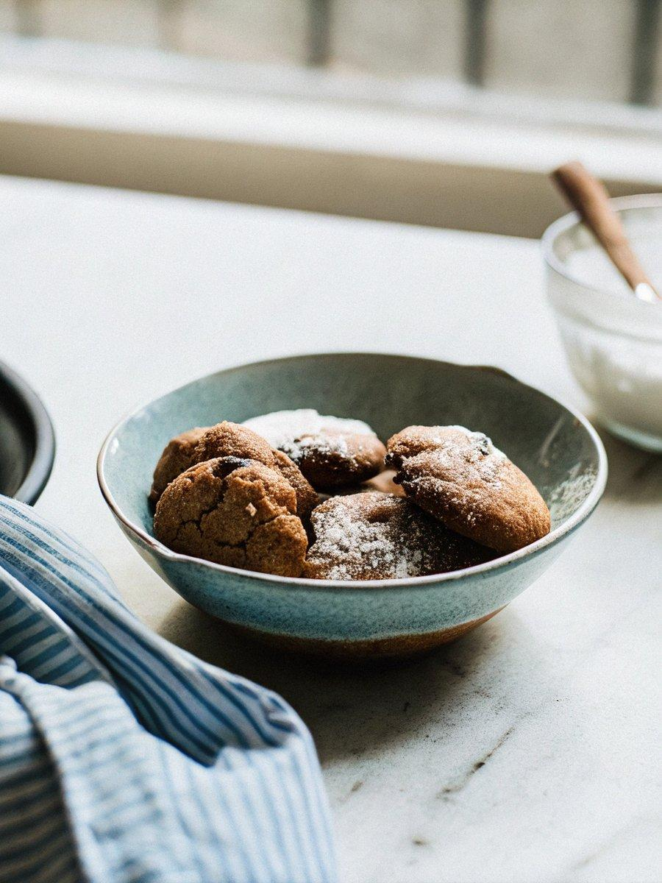

INGREDIENTS  - 1 cup (240ml) unsalted butter (227 g, unsalted, room temp)  - 1 cup (240ml) granulated sugar (234 g)  - 2 eggs  - 4 cups (960ml) all-purpose flour (500 g, sifted)  - 3/4 cup cornstarch (80 g, sifted)  - 3/4 tsp kosher salt (4 g)  - 1 tbsp vanilla extract (15 mL)  - 1/4 cup pink sanding sugar (50 g)  - few drops pink food coloring | PREP  COOK  1. It's easiest to make two separate batches of cookie dough; one uncolored and one pink just use half the ingredients for each batch. You can however make a big batch of dry and a big batch of wet ingredients then divide in half using a scale, color one and mix. In these instructions we will be making two batches starting with the uncolored batch.  2. Sift 2 cups (480ml) flour, 40g cornstarch, and about 1/3 tsp salt into a large bowl then whisk to incorporate.  3. In a stand mixer fitted with a paddle attachment cream 1/2 cup room temperature butter, and 1/2 cup sugar together.  4. Mix in 1 1/2 tsp vanilla extract, then one egg to the sugar/butter mixture.  5. Add 1 egg to each sugar/butter mixture.  6. On low, mix in dry mixture until almost combined. Scrape the bowl down then mix once more until just combined.  7. Roll out to a 1/4-inch (10cm) thickness then transfer onto a baking sheet and place in refrigerator to chill. I like to roll my cookie dough between two layers of plastic for ease of transfer and clean up.  8. Now it's time to make the pink batch. Repeat the above steps but add in a few drops of soft pink food coloring to the butter sugar mixture along with the vanilla.  9. Roll out as before and sprinkle about ¼ cup pink sanding sugar onto the pink batch. Give a gentle roll to press the pink sugar into the dough.  1  0. Cover with plastic, transfer to a baking sheet and chill for at least 20 minutes to firm up.  1  1. Once the dough has chilled use a ruler and a sharp knife to cut ½ inch strips of dough. Return to fridge while you work on the next batch.  1  2. Layer pink and white stripes so that they are touching.  1  3. Cover dough with a sheet of plastic wrap or parchment paper then roll to create a seal. Transfer to the fridge to chill on last time.  1  4. Preheat to 375°F (190°C).  1  5. Cut cookies with a heart shaped cutter.  1  6. Carefully lace cookies on a baking sheet lined with parchment paper or a silicone baking sheet.  1  7. Bake for about 12 minutes then allow to cool before enjoying.  PLATING

