PERFECT ROAST LEG OF LAMB  COOK TIME: 2h 20m  SOURCE:  #comfort-food #roasted #hearty | 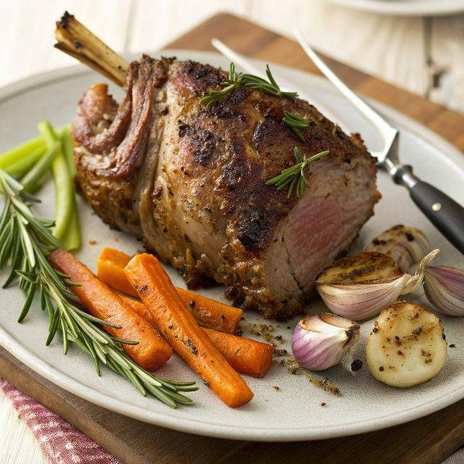

INGREDIENTS  - 2 sticks of celery  - 2 carrots  - 2 onions  - 2 bay leaves  - 1 large leg of higher-welfare lamb (2.4 kg)  - olive oil  - 1/2 a bunch of fresh rosemary (15 g)  - 4 cloves of garlic  - red wine vinegar  - optional: 9 anchovy fillets | PREP  COOK  1. Preheat the oven to 220°C/425°F (220°C)/gas  7. Roughly chop the celery, carrots and onions, throwing into a large roasting tray as you go, with the bay leaves.  2. With a sharp, pointed knife, follow the lamb bone down about 10cm (4-inch) to 12cm (you are just making a ‘tunnel’ where you are cutting the meat away from the bone). Do this from the top end and the bottom end. Pierce the skin at an angle with a sharp pointed knife 6 or 8 times at random around the leg, then open up the incisions by poking your fingers down them to make a bit of space. Rub the lamb all over with olive oil, sea salt and black pepper.  3. Strip the leaves off the rosemary sprigs and peel and finely slice the garlic, then toss in a little drizzle of olive oil and a splash of red wine vinegar. Push a little rosemary, a couple of slices of garlic and an anchovy fillet (if using) into each hole, adding any leftovers and a good splash of water to the trivet tray with the veg.  4. Place the lamb directly on the bars of the middle shelf of the oven, and place the tray on the shelf beneath. Turn the oven down to 180°C/350°F (175°C)/gas 4 and cook to your liking (see timings below).  PLATING

