CHOCOLATE BUTTERCREAM FROSTING (6-MINUTE RECIPE)  COOK TIME: 6 min  SOURCE:  #quick #chocolate #frosting | 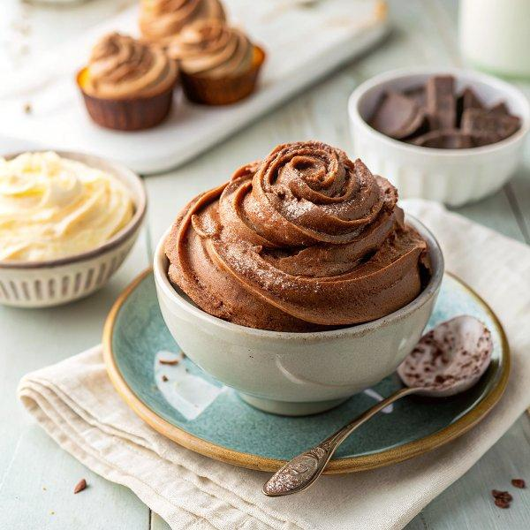

INGREDIENTS  - 1 cup (240ml) unsalted butter (softened)  - 3 cups (720ml) confectioners sugar  - 1/2 cup unsweetened natural cocoa powder  - 3 to 4 Tbsp heavy whipping cream (plus more to thin the frosting)  - 2 tsp pure vanilla extract  - 1/4 tsp salt | PREP  COOK  1. With a handheld mixer or stand mixer fitted with a whisk attachment, beat butter on high speed for about 3 minutes or until creamy and lightened in color, scraping down the bowl as needed.  2. Add confectioners sugar, cocoa powder, 3 Tbsp heavy cream, 2 tsp vanilla extract, and 1/4 tsp salt.  3. Beat on low speed until sugar is incorporated then increase to medium/high speed and beat for 3 minutes, scraping down the bowl several times to ensure everything is well blended. Add another Tablespoon of heavy cream if needed to thin the frosting.  PLATING

