CREAMY CHICKEN KORMA  COOK TIME: 30 min  SOURCE:  #comfort-food #curry #quick | 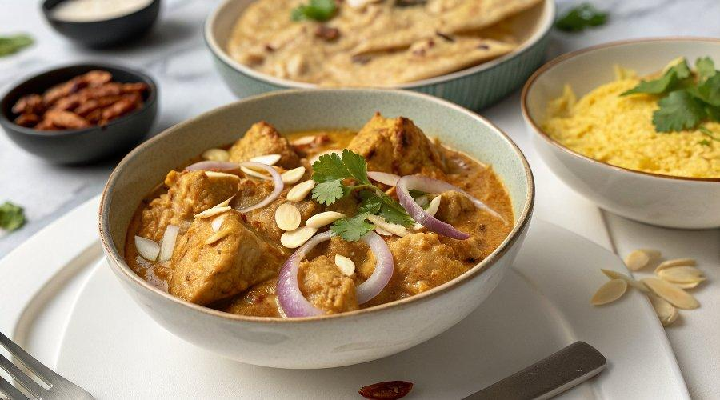

INGREDIENTS  - 2 onions (320 g)  - olive oil  - 1/2 a bunch of fresh coriander (15 g)  - 2 x free-range skinless chicken breasts  - 25 g ground almonds  - 1 jar of Jamie Oliver Creamy Korma paste  - 200 ml organic chicken stock  - 2 x 400 g tins of chickpeas  - 200 g Greek yoghurt, plus extra to serve  - mango chutney, to serve  - 25 g flaked coconut  - 25 g flaked almonds  - optional: a pinch of dried chilli flakes  - All-Rounder Board | PREP  COOK  1. Peel and finely slice the onions, then place in a deep pan on a medium-high heat with 1 tablespoon of olive oil. Finely slice and stir in the coriander stalks (putting the leaves aside for later). Cook for 10 minutes, or until the onions start to caramelise, stirring regularly.  2. Chop the chicken breasts into 2cm (1-inch) chunks, add to the pan and fry for 5 minutes, or until golden.  3. Add the ground almonds and stir through the curry paste. Cook for 1 minute, then pour in the chicken stock and chickpeas (juice and all). Simmer for 10 minutes, or until cooked through, stirring occasionally, then stir through the yoghurt.  4. Meanwhile, toast the flaked coconut and flaked almonds with the chilli flakes, if using, in a frying pan on a medium heat, until golden and fragrant.  5. Scatter over the coconut topping and reserved coriander leaves, and serve with the mango chutney and extra dollops of yoghurt.  PLATING

