ALMOND CAKE  COOK TIME: 20 min  SOURCE:  #cake #almond #sweet | 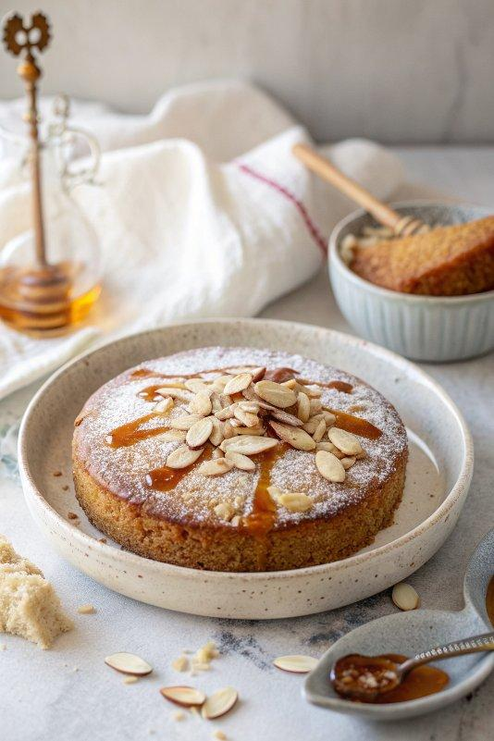

INGREDIENTS  - 1/4 cup sliced raw almonds (plus more for serving)  - 2 cups (480ml) fine blanched almond flour  - 2 tsp baking powder  - 1/4 tsp salt  - 3 eggs  - 1/2 cup maple syrup  - 2 tbsp olive oil or avocado oil  - 1 tsp almond extract  - 1/2 tsp vanilla extract  - Powdered sugar (for serving, optional) | PREP  COOK  1. Preheat oven to 350F and spray an 8” springform pan or 8" round cake pan with cooking spray.  2. Toast  3. Once oven is preheated add sliced almonds to a small baking tray and place in the oven to toast for 4-5 minutes or until golden brown. Watch closely to make sure they don’t burn! Once toasted, remove from oven and set aside to cool.  4. Mix dry ingredients  5. In a medium mixing bowl combine the dry ingredients (almond flour, baking powder and salt).  6. Mix wet ingredients  7. In a separate large mixing bowl whisk together the wet ingredients (eggs, maple syrup, oil, vanilla extract and almond extract) until smooth and combined.  8. Combine  9. Add dry ingredients to wet ingredients and mix together until fully combined and smooth.  1  0. Top  1  1. Transfer batter to your prepared springform pan. Evenly sprinkle toasted almond slices on top of the cake.  1  2. Bake for 20-25 minutes or until top is slightly golden and toothpick inserted comes out clean.  1  3. Cool and serve  1  4. Remove from oven and let cool in the pan. One cool, sprinkle powdered sugar on top with additional raw almond slices if desired and serve!  PLATING

