NUTELLA TART WITH TOASTED HAZELNUT CRUST  COOK TIME: 20 min  SOURCE:  #chocolate #sweet #baked | 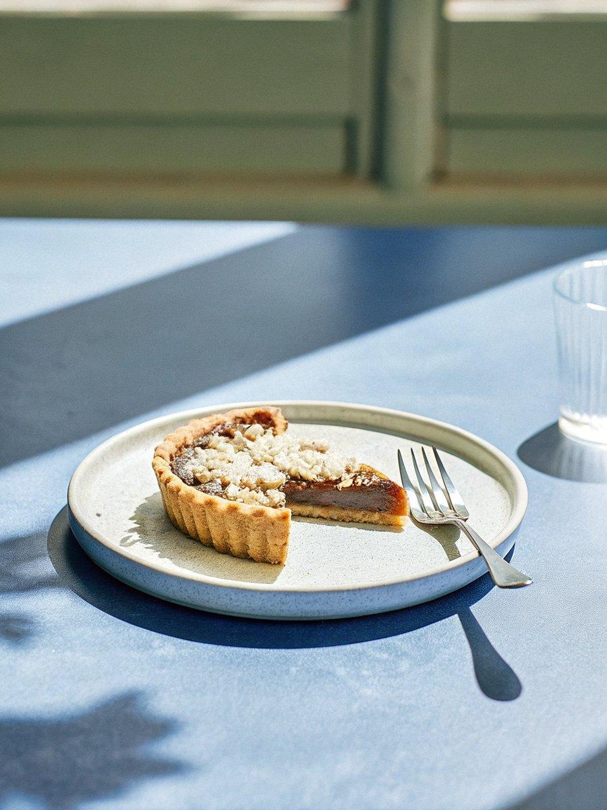

INGREDIENTS  - 1 cup (120 g) chopped unsalted hazelnuts  - 1 cup (125 g) all-purpose flour (spooned & leveled)  - 2 tbsp (25 g) granulated sugar  - 1/2 tsp salt  - 1/2 cup (8 Tbsp; 113 g) unsalted butter, cold and cubed  - 3 tbsp (45 ml) ice water  - 2 tbsp (14 g) cornstarch  - 2 cup (480ml)s (480 g) heavy cream  - 3/4 cup (225 g) Nutella  - 1/8 tsp salt  - 1 tsp pure vanilla extract | PREP  COOK  1. I encourage you to check out the step-by-step photos below this recipe before beginning.  2. Preheat the oven to 300°F (149°C). Spread chopped hazelnuts out onto a parchment paper or silicone baking mat lined baking sheet. Toast until slightly darkened, about 5-7 minutes. Allow to cool down for 5 minutes. Turn the oven up to 350°F (177°C)  3. For the crust  4. Using a food processor, pulse 3/4 cup of the toasted hazelnuts, the flour, sugar, and salt together until it reaches the consistency of coarse meal. (Reserve 1/4 cup of the nuts for topping.) Add the cubes of cold butter and pulse until the mixture turns into pea-sized crumbs.  5. Transfer mixture to a large bowl. Using a silicone spatula or wooden spoon, slowly stir in 3 Tablespoons of ice water. You only want to add enough water to bring the dough somewhat together. Using floured fingers or the bottom of a flat and lightly floured measuring cup, press the dough evenly into a 9-inch (23cm) tart pan. You want it extremely tight in the pan. You’ll need to use pie weights for the next step, so line the crust with aluminum foil or parchment paper and add pie weights.  6. Bake (with pie weights) for 18-20 minutes. Remove from the oven and place on a wire rack so it can slightly cool as you prepare the filling.  7. For the filling  8. Whisk the cornstarch and 1/2 cup of the heavy cream together in a small bowl. (You want a little cream mixed with the cornstarch to avoid white cornstarch lumps in your filling.) Combine the cornstarch mixture, the rest of the heavy cream, Nutella, and salt into a medium saucepan over medium heat. Whisk to combine all of the ingredients and bring to a boil. While constantly whisking, allow to boil for 3 minutes as it thickens. Remove from heat, whisk in the vanilla, then pour into the crust, swirling the top for a pretty pattern (if desired!).  9. Chill in the refrigerator for 3-4 hours or until set. Top with remaining hazelnuts.  PLATING

