UBE BUNS  COOK TIME: 20 min  SOURCE:  #baking #comfort-food #sweet | 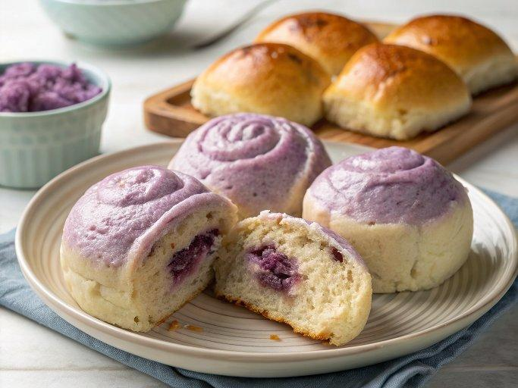

INGREDIENTS  - 2/3 cup heavy cream (at room temperature)  - 1 cup (240ml) milk (at room temperature (whole milk is ideal, but can also use 1% or 2% milk)  - 1 large egg (at room temperature)  - 1/3 cup granulated sugar  - 1/2 cup cake flour  - 3 1/2 cups bread flour  - 1 tbsp active dry yeast  - 1 1/2 tsp salt  - egg wash (whisk together 1 egg with 1 tsp water)  - 1 tbsp sesame seeds (black or white sesame seeds, optional)  - simple syrup (optional: 2 tsp of sugar dissolved in 2 tsp hot water)  - 14 oz raw, trimmed, peeled ube  - 1/4 tsp salt  - 3 tbsp granulated sugar (or to taste)  - 1/2 tsp vanilla extract  - 1/4 cup coconut oil  - 1 tbsp unsalted butter | PREP  COOK  1. Make the milk bread dough (see "Dough Notes" box in post for more detail):  2. In the bowl of a stand mixer, add ingredients in the following order: heavy cream, milk, egg, sugar, cake flour, bread flour, yeast, and salt. Use the dough hook attachment, and turn on the mixer to “stir.” Let it go for 15 minutes, occasionally stopping the mixer to push the dough together.  3. If you’re in a humid climate and the dough is too sticky, feel free to add a little more flour 1 tablespoon at a time until it comes together. It should be a little sticky and elastic—sticking to the bottom of the mixing bowl is okay. It should not stick to the sides of the bowl. (If you don’t have a mixer and would like to knead by hand, extend the kneading time by 5-10 minutes.)  4. After 15-25 minutes of kneading, the dough is ready for proofing. Cover the bowl with a damp towel and place in a warm spot for 1 to 2 hours. I proof my dough in the microwave with a large mug of boiling water next to it. With the microwave door closed, the moisture and the heat from the boiling water is ideal for proofing.  5. Make the ube filling:  6. While the dough is proofing, trim and peel the ube, and cut it into 1-inch (2.5 cm) chunks. Steam for 30 minutes on high heat until fork-tender. Remove from heat, preserving any liquid in the dish from steaming.  7. While it’s still hot, add the salt, sugar (as called for or to taste), vanilla extract, coconut oil, and unsalted butter. Using a potato masher or food processor, mash the ube until it’s smooth and the sugar is completely dissolved. Cover and set aside.  8. Assemble and bake:  9. After the first proofing, put the dough back in the mixer and knead for another 5 minutes to get rid of air bubbles.  1  0. Divide the dough into 12 equal pieces. (You can eyeball this, but for best results, weigh the dough and divide that number by  1  2. Then weigh each individual piece of dough to match that number. Do the same with the filling.  1  1. Knead each individual piece of dough into a smooth ball. Using a lightly floured rolling pin, roll each piece of dough into a 4.5x8-inch (11.5x20 cm) rectangle/oval.  1  2. Spread the ube filling onto the dough in a flat, even layer, leaving a ½-inch (1.25 cm) border around the edges. Starting from one of the short sides of the dough, tightly roll it into a cigar to enclose the filling inside. Pinch the seam and both ends closed, tucking them underneath the bun.  1  3. Once shaped, let the dough proof for another hour. 15 minutes before the buns are done proofing, position a rack in the middle of the oven, and preheat it to 350°F/175°C.  1  4. Brush the risen dough with egg wash, sprinkle lightly with sesame seeds if using, and bake for 16-18 minutes.  1  5. Remove from the oven, and immediately brush the buns with sugar water to give them a great shine, sweetness, and color.  PLATING

