SAUTEED BRUSSELS SPROUTS RECIPE  COOK TIME: 20 min  SOURCE:  #quick #healthy #vegetable | 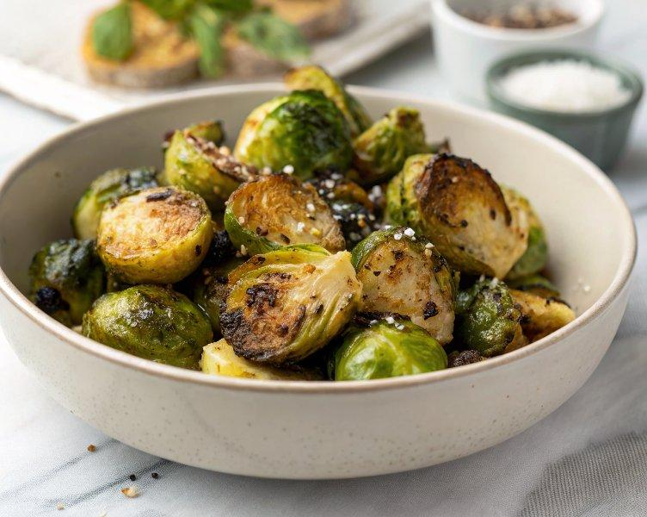

INGREDIENTS  - 1 lb. Brussels sprouts ($3.66)  - 4 Tbsp olive oil, divided ($0.48)  - 1/4 tsp salt, divided ($0.02)  - 1/4 tsp freshly cracked black pepper, divided ($0.02)  - 1/4 tsp garlic powder, divided ($0.02)  - 1 Tbsp butter ($0.14)  - 1 Tbsp balsamic vinegar ($0.15) | PREP  COOK  1. Wash and dry the Brussels sprouts, then trim off the dry ends. Cut each Brussels sprout in half lengthwise.  2. Sear  3. Add 2 Tbsp of oil to a large cast iron skillet* over medium heat. Add half of the brussels sprouts to the skillet in a single layer, cut side down. Let the sprouts cook for about 3-4 minutes on the first side without moving them around. This allows them to get a good sear and turn golden brown.  4. Cook  5. Now give the Brussels sprouts a quick stir and season with half of the salt, black pepper, and garlic powder. About ⅛ tsp of each. Let the Brussels sprouts continue to cook for about 5-6 more minutes, stirring occasionally, until tender.  6. Sear  7. Remove the sprouts from the pan to a separate plate. Add another 1-2 Tbsp of oil and repeat the steps with the other half of the Brussels sprouts and seasonings.  8. Toss  9. Once the second batch of Brussels sprouts is done, add the first batch back to the skillet along with the butter and balsamic vinegar. Toss everything together and cook for another minute until all the Brussels sprouts are warmed through. Serve warm and enjoy!  PLATING

