OAT TORTILLAS  COOK TIME: 10 min  SOURCE:  #quick #healthy #homemade | 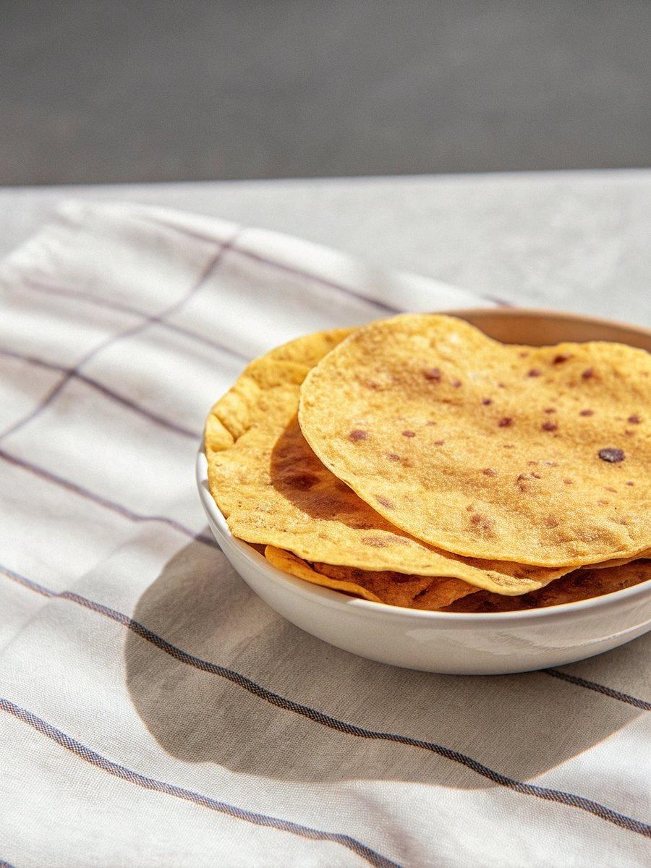

INGREDIENTS  - 2 cups (480ml) oats (gluten-free if needed)  - 2 scant cups water  - 1/2 tsp salt (optional) | PREP  COOK  1. You can watch the video for visual instructions.First, blend the oats into a fine flour in a high-speed blender.  2. Meanwhile, bring the water and salt to a boil in a large, non-stick pan.  3. Sift the oat flour into the boiling water, stirring constantly with a spatula until the dough thickens and pulls away from the sides of the pan. This will take several minutes.  4. Leave the dough to cool until it’s easy to handle, then lightly oil your hands, roll it into a log, and divide it into 8-9 equal pieces.If the dough is sticky, it probably wasn’t cooked for long enough. Knead a small amount of extra oat flour into it, if needed.  5. Roll each piece into a ball, keeping the rest covered to prevent drying.  6. Place each dough ball between two layers of wax paper, parchment paper, or a cut Ziplock bag, then evenly press it into a tortilla using a tortilla press, heavy cutting board, or cast-iron skillet. Aim for 2-3mm thickness.  7. Working one at a time, cook each tortilla in a hot skillet over medium heat (no oil needed) until warm with brown spots on both sides.  PLATING

