CARAMEL APPLE BLONDIES  COOK TIME: 40 min  SOURCE:  #quick #comfort-food #baking | 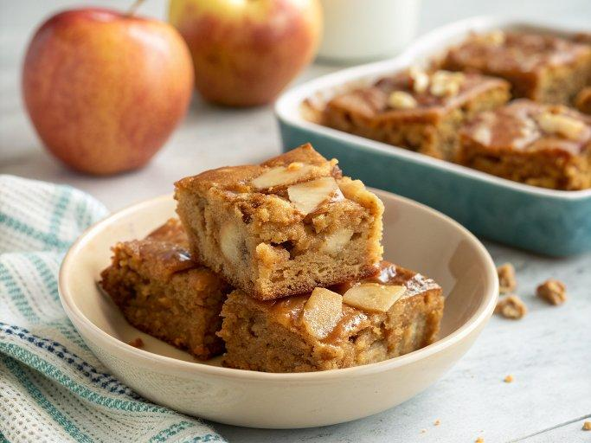

INGREDIENTS  - 1 1/2 cups all-purpose flour or gluten-free flour mix (see below)  - 1 tbsp ground cinnamon plus 1/2 tsp (divided)  - 1/8 tsp ground nutmeg  - 1/2 tsp baking powder  - 1/4 tsp baking soda  - 1/2 tsp fine sea salt  - 1/2 cup unsalted butter (melted)  - 1 1/2 cups light brown sugar (lightly packed)  - 1 tsp pure vanilla extract  - 2 large eggs (room temperature)  - 1 1/2 cups peeled Granny Smith apple chunks (about 1/4" in size)  - 1 1/2 cups white rice flour  - 1/3 cup potato starch  - 2 tbsp + 2 tsp tapioca flour/starch  - 1/2 tsp xanthan gum  - 1 cup (240ml) chopped pecans  - 6 tbsp light brown sugar (lightly packed)  - 3 tbsp unsalted butter  - 2 tbsp plus 1 tsp milk  - Pinch fine sea salt  - 1 tsp pure vanilla extract  - 2/3 to 1 cup (240ml) powdered sugar (sifted if lumpy) | PREP  COOK  1. Preheat the oven to 350°F (175°C) and line an 8x8-inch (20x20cm) pan with a sheet of parchment paper.  2. In a medium mixing bowl, stir together the flour (all-purpose or the gluten-free mix), 1 tablespoon cinnamon, nutmeg, baking powder, baking soda and salt. Set aside.  3. In a large mixing bowl, stir together the melted butter, brown sugar, and vanilla extract.  4. Beat in the eggs, one by one, and stir just until combined.  5. Fold in the dry mixture, stirring just until no streaks of flour remain.  6. Mix the peeled apple chunks with the remaining 1/2 teaspoon of cinnamon and fold the cinnamon apples into the batter, making sure not to overmix.  7. Pour the batter into the prepared pan and bake for 40 minutes or until the center is set and a toothpick inserted into the center comes out with moist crumbs clinging to it. Set on a rack to cool.  8. Place the pecans on a rimmed cookie sheet and bake them for 4-7 minutes, stirring them halfway through, or until they smell roasted. Remove from the oven and set aside.  9. In a small saucepan over medium heat, mix together the brown sugar, butter, milk and salt.  1  0. Whisking continuously, bring the mixture to a boil and boil for 1 minute, while continuing to whisk continuously. Remove the pan from the heat and stir in the vanilla (it will bubble).  1  1. Gradually whisk in 2/3 cup powdered sugar and mix until smooth and no lumps of sugar remain. Taste and add up to another 1/3 cup powdered sugar, if desired.  1  2. Pour the frosting over the warm blondies and spread evenly over the top. Top with the chopped pecans. Let the blondies finish cooling.  PLATING

