VEGAN LENTIL ‘BOLOGNESE’  COOK TIME: 30 min  SOURCE:  #comfort-food #healthy #quick | 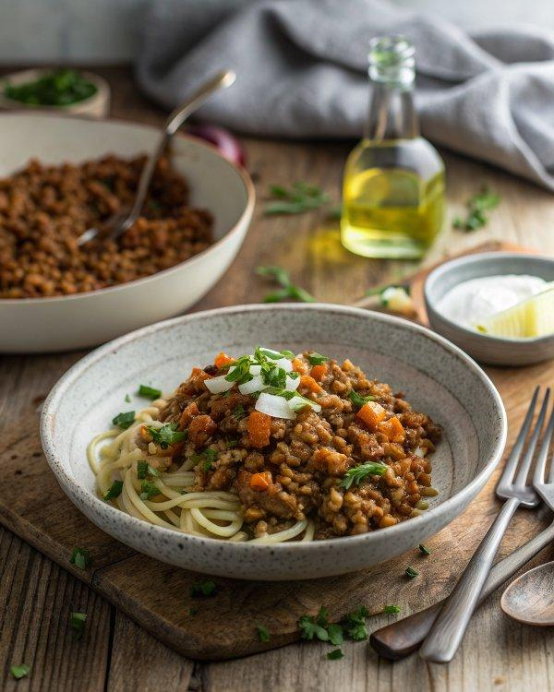

INGREDIENTS  - 280 g/10 oz/scant 1 1/2 cups dried brown or green lentils  - 5 tbsp extra virgin olive oil, plus extra for drizzling  - 1 small onion, finely chopped  - 1 celery stalk, finely chopped  - 1 small carrot, finely chopped  - 100 g/3 1/2 oz/scant 1/2 cup pumpkin flesh, finely chopped  - 2 garlic cloves, whole, peeled and crushed  - 200 g/7 oz/scant 1/4 cup chestnut button mushrooms, thinly sliced  - 2 bay leaves  - 400ml (1.7 cups)/14 fl oz/1 3/4 cups tomato passata (strained tomatoes)  - 900ml (3.8 cups)/31 fl oz/3 1/2 cups hot vegetable stock (or use a stock cube)  - 500 g/1 lb 2 oz/scant 4 cups (960ml) dried egg-free pappardelle pasta  - rustic bread, to serve (optional)  - chilli flakes, to serve (optional) | PREP  COOK  1. Rinse the lentils under plenty of cold water, checking for any impurities.  2. Heat the olive oil in a pan, then sweat the onion, celery, carrot, pumpkin and garlic on a medium heat for a couple of minutes. Stir in the lentils, mushrooms and bay leaves and cook for a couple of minutes.  3. Add the passata and stock, bring to the boil, then lower the heat and gently simmer for about 1 hour, until the lentils are cooked. You may need more or less stock depending on the type of lentils, so add this gradually.  4. Near the end of the cooking time, bring a large pot of salted water to the boil and cook the pasta until ‘al dente’. Using tongs, transfer the pasta to the lentil ragu, mixing well and adding a little of the hot pasta water to loosen the sauce.  5. Remove from the heat and serve with rustic bread, a drizzle of olive oil and some chilli flakes, if desired.  PLATING

