CREAMY BROCCOLI & BLUE CHEESE GNOCCHI  COOK TIME: 25 min  SOURCE:  #comfort-food #pasta #creamy | 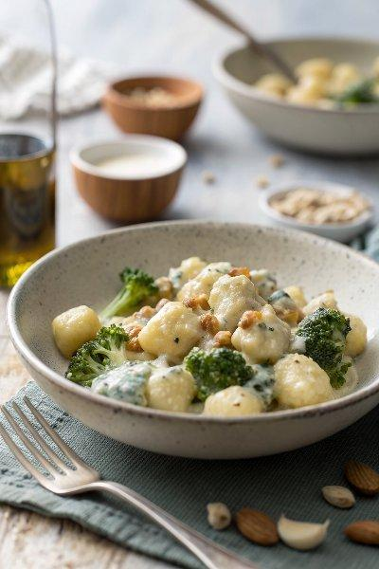

INGREDIENTS  - 500 g floury potatoes, such as Maris Piper  - 1 tbsp blanched hazelnuts  - 3 sprigs of fresh sage  - olive oil  - 2 small onions  - 2 cloves of garlic  - 1/4 of a whole nutmeg, for grating  - 40 g plain flour, plus extra for dusting  - 160 g frozen broccoli  - 50 g blue cheese (frozen)  - 4 tbsp double cream | PREP  COOK  1. Scrub and prick the potatoes, then microwave on full power (800W) for 10 minutes, or until soft.  2. Place the hazelnuts in a large non-stick frying pan on a medium heat to toast. Pick in half the sage leaves, spritz with olive oil and fry for 3 minutes, or until the nuts are lightly golden and the sage is crispy, tossing regularly. Roughly bash in a pestle and mortar.  3. Peel and finely slice the onions and garlic, place in the frying pan with 1 tablespoon of oil, then season to perfection with sea salt and black pepper. Roughly chop and add the remaining sage leaves, and fry for 5 to 10 minutes, or until caramelised, stirring regularly, then reduce the heat to low.  4. Cut the potatoes in half and use a potato masher to squash out the fluffy middles, removing the skins (see tips). Mash the fluffy insides, grate in the nutmeg and season to perfection, then lightly mash in the flour.  5. Knead on a clean, flour-dusted surface until smooth and pliable, divide in half and roll into 2 long sausage shapes (roughly 2cm thick), then slice into 3cm (1-inch) pieces to make your gnocchi. Pinch the middles, or add texture below (see tips).  6. Cook the broccoli in a large pan of boiling salted water for 3 to 4 minutes, then transfer it to the frying pan with a slotted spoon, keeping the pan of water on the heat. Break up the broccoli and mash with a spoon, then finely grate in most of the cheese and add all the cream.  7. Cook the gnocchi in the pan of water for 2 to 3 minutes – as soon as they come up to the surface, they’re ready. Use a slotted spoon to carefully transfer them to the sauce, adding a splash of cooking water to loosen, if needed.  8. Gently toss until you have a silky, creamy sauce, then serve right away with the hazelnut and sage sprinkle and an extra grating of cheese.  PLATING

