ROASTED PUMPKIN SEEDS (PEPITAS)  COOK TIME: 25 min  SOURCE:  #healthy #quick #snack | 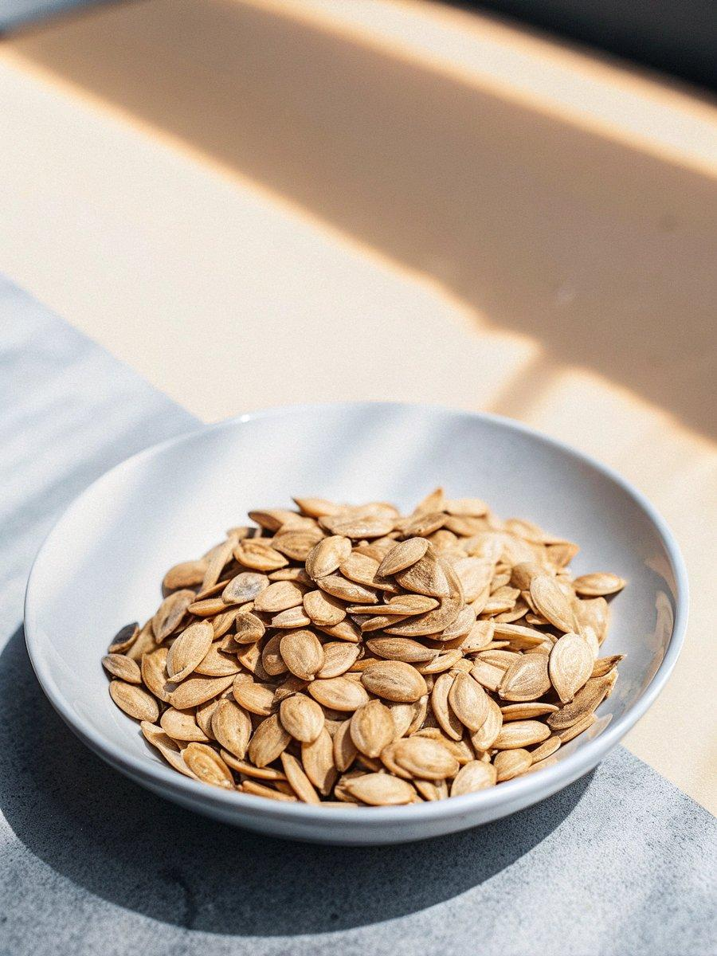

INGREDIENTS  - pepitas (raw, hulled pumpkin seeds)  - olive oil, melted butter or cooking spray (preferably olive oil)  - salt  - seasonings  - salt  - garlic salt  - chili powder + lime juice  - herbs de provence (or Italian seasoning)  - smoked paprika  - cinnamon + chili powder  - worcestershire sauce + seasoned salt | PREP  COOK  1. Preheat oven to 350 degrees. Grease baking sheet or line with aluminum foil.  2. In a bowl, mix pumpkin seeds with a small amount of olive oil (or butter, or lightly cover with cooking spray); use just enough oil so that they are just very lightly coated. Add salt and seasoning to taste, and mix so that seeds are fairly evenly coated.  3. Transfer seeds to cooking sheet, and bake for about 15-25 minutes (or until seeds are cooked and begin to lightly brown). Remove trays every 10 minutes to stir the seeds and check for doneness. Let cool and serve.  PLATING

