ULTRA FUDGY SEA SALT CARAMEL BROWNIES  COOK TIME: 10 min  SOURCE:  #chocolate #sweet #comfort-food | 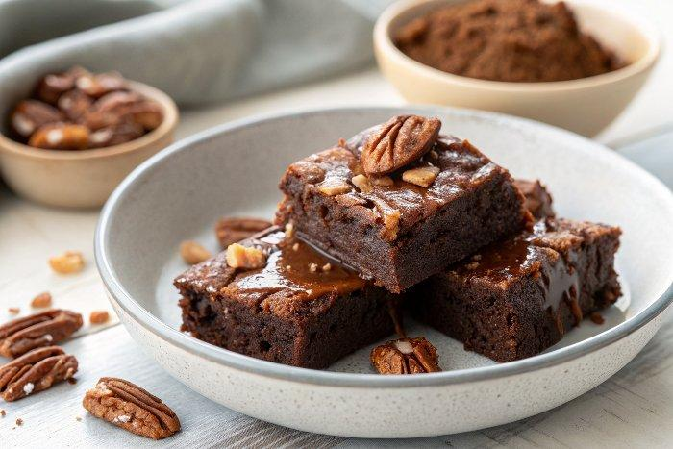

INGREDIENTS  - 2 cup (480ml) Medjool date  - 2 Tbsp refined coconut oil  - 1/2 cup Dutch-process cocoa powder  - 1 Tbsp water  - 1/2 cup unsalted roasted pecans  - 1.764 oz dairy-free dark chocolate  - 1 pinch flaky sea salt | PREP  COOK  1. Line a 9 x 9 inch (21 x 21 cm) baking dish. Preheat the oven to 350°F (180°C)*.  2. In a food processor, blend the dates, coconut oil, cocoa powder, and water until smooth**.  3. Add the pecans, chocolate, and salt. Blend again, but let some chunks remain.  4. Transfer the mixture into the prepared baking dish, and spread evenly. Bake for 10 minutes***.  5. When removed from the oven, top with some more crushed pecans, chopped chocolate, and a sprinkle of sea salt if desired. Gently press these in to secure them.  6. Let cool before cutting. These brownies are fudgiest if kept in the fridge. Enjoy!  PLATING

