SMOKY CHIPOTLE CHICKEN SOUP  COOK TIME: 25 min  SOURCE:  #comfort-food #quick #spicy | 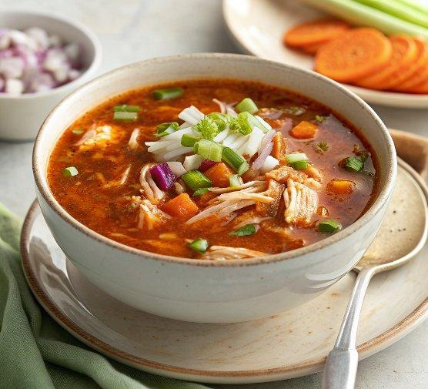

INGREDIENTS  - 1 tbsp olive oil  - 2 onions finely chopped  - 4 carrots finely chopped  - 2 celery sticks finely chopped  - 1 1⁄2 L low-salt chicken stock  - 1-2 tbsp chipotle paste (depending on how much spice you prefer)  - 400 g leftover cooked chicken shredded  - 200 g frozen peas  - 1 lemon zested and juiced  - 4 tbsp low-fat crème fraîche  - 2 garlic cloves crushed  - 1⁄4 tsp chilli flakes to serve (optional) | PREP  COOK  1. Heat the oil in a large saucepan over a medium heat, add the onions, carrots and celery, and fry for 8 mins until softened, stirring occasionally. Stir in the stock and chipotle, bring to the boil, and simmer for 10 mins.  2. Ladle half of the soup into a blender and blitz. Pour the blitzed soup back into the pan, then add the chicken, peas, lemon juice and some seasoning (use smoked salt, if you have it). Simmer for 5 mins to warm through.  3. Stir the lemon zest into the crème fraîche along with the garlic and 2 tbsp water to loosen.  4. Divide the soup between bowls, swirl in the crème fraïche and top with the chilli flakes, if using.  PLATING

