JAMAICAN OXTAIL  COOK TIME: 3h  SOURCE:  #comfort-food #hearty #slow-cooked | 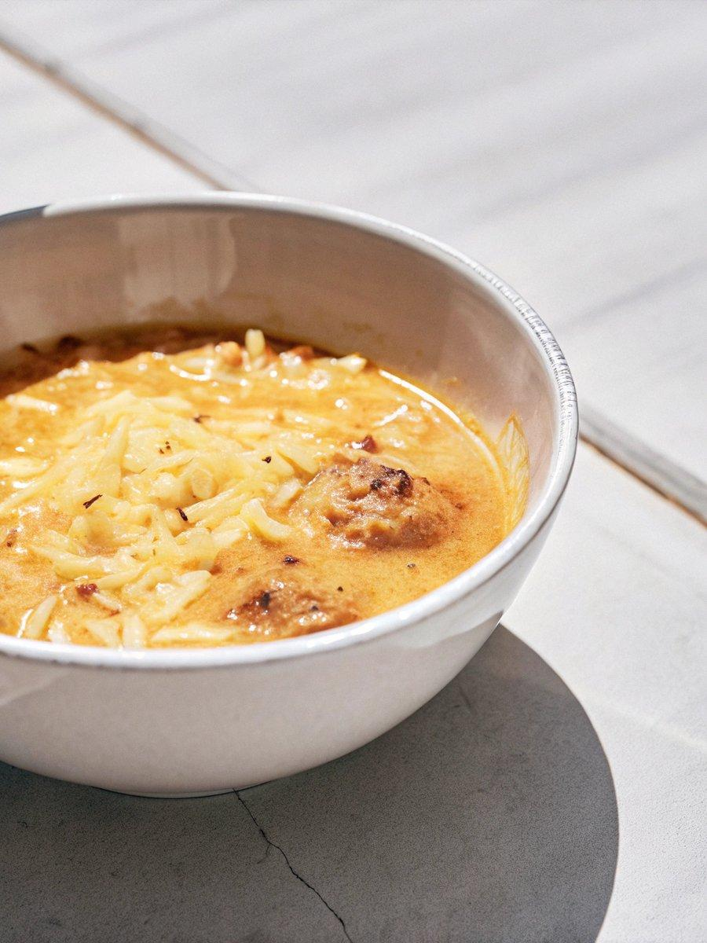

INGREDIENTS  - 2 onions roughly chopped  - 2 spring onions roughly sliced  - 4 garlic cloves finely chopped  - 2 tbsp ginger finely chopped  - 12 g thyme sprigs leaves picked (see tip below)  - 90 ml soy sauce  - 1 kg oxtail ask your butcher to chop cut into 1-inch (3cm) thick chunks  - 3 tbsp cornflour  - 2 tbsp sunflower oil  - 2 scotch bonnet peppers (add more if you prefer more heat)  - cooked white rice or rice and peas | PREP  COOK  1. Tip the onions, spring onions, garlic, ginger, thyme, soy sauce, a large pinch of salt and 1 tsp freshly ground black pepper into a bowl. Mix well and add the oxtail, turning to coat. Keep chilled overnight, or for at least 12 hrs.  2. When ready to cook, remove the oxtail from the marinade (reserve the marinade), put on a plate and dust lightly with the cornflour. Heat the oil in a large, deep saucepan or casserole dish and sear each piece of oxtail on both sides, around 2-3 mins each side, working in batches. Set the oxtail aside on a plate, then pour the reserved marinade into the saucepan and cook for 2-3 mins, scraping the bottom with a wooden spoon to release any browned bits.  3. Return the oxtail to the pan then add enough water to just cover the meat, around 800ml (3.3 cups) should suffice. Mix in the scotch bonnets, then bring to boil. Cover and cook on low for 2 hrs 30 mins – 3 hrs until the meat slips off the bone. Season to taste and serve with cooked white rice, or rice and peas.  PLATING

