APPLE CRANBERRY PIE  COOK TIME: 1h  SOURCE:  #comfort-food #baked #seasonal | 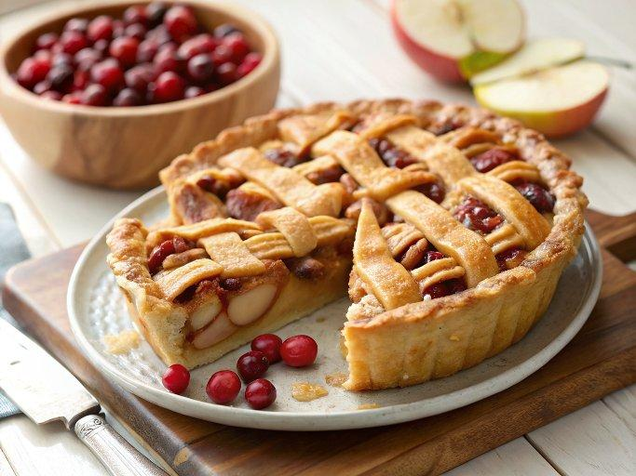

INGREDIENTS  - homemade pie crust (my recipe makes 2 crusts; 1 for bottom 1 for top)*  - 3 large apples, cored, peeled, and sliced into 1/4-inch (10cm) slices (about 6–7 cups of slices, or 750–875 g)  - 1 and 1/2 cups (187 g) fresh or frozen cranberries  - 3/4 cup (150 g) granulated sugar  - 2 tbsp (14 g) cornstarch  - 1 tsp fresh orange zest  - 1 and 1/2 tsp ground cinnamon  - 1/4 tsp ground cloves  - 1/4 tsp ground nutmeg  - 2 tbsp (30 g) unsalted butter, cold and cubed  - egg wash: 1 large egg beaten with 1 tbsp (15 ml) milk | PREP  COOK  1. The crust  2. Prepare my pie crust recipe through step  5.  3. Make the filling  4. Stir the apples, cranberries, granulated sugar, cornstarch, orange zest, cinnamon, cloves, and nutmeg together in a large bowl. Set filling aside as the oven preheats.  5. Preheat oven to 400°F (204°C).  6. Roll out the chilled pie dough  7. On a floured work surface, roll out one of the discs of chilled dough (keep the other one in the refrigerator). Turn the dough about a quarter turn after every few rolls until you have a circle 12-inch (30cm) in diameter. Carefully place the dough into a 9-inch (23cm) pie dish. Tuck it in with your fingers, making sure it is smooth. Spoon the filling into the crust, leaving any excess liquid in the bowl (you don’t want that in the filling—discard it). Dot the pieces of butter on top of the filling. Stick in the refrigerator until ready to cut the lattice.  8. Arrange the lattice  9. Remove the other disc of chilled pie dough from the refrigerator. Roll the dough into a circle that is 12-inch (30cm) diameter. Using a pastry wheel, sharp knife, pizza cutter, or this fun ribbon cutter, cut strips 1 or 2-inch (5cm) wide. Remove the pie from the refrigerator and carefully thread the pie dough strips over and under one another, pulling back strips as necessary to weave. Press the edges of the strips into the bottom pie crust edges to seal. Use a small knife to trim off excess dough. Crimp or flute the pie crust edges. See recipe notes for making the braid or apple shapes! (Alternatively, you can simply cover the filling with the 12-inch pie dough circle. Cut slits in the top to form steam vents. Trim and crimp the edges. Or crumble topping (from apple crumble pie) or streusel topping (from peach pecan crisp) would be great as well.)  1  0. Lightly brush the top of the pie crust with the egg wash mixture.  1  1. Place the pie onto a large baking sheet and bake for 20 minutes. Keeping the pie in the oven, turn the temperature down to 350°F (177°C) and bake for an additional 30-35 minutes. After the first 20 minutes of bake time, I place a pie crust shield on top of the pie to prevent the edges from browning too quickly.  1  2. Allow the pie to cool for 3 full hours at room temperature before serving. This time allows the filling to thicken up. Cover leftovers tightly and store in the refrigerator for up to 5 days.  PLATING

