CHEUNG FUN WITH SHRIMP (鲜虾肠粉)  COOK TIME: 1h 20m  SOURCE:  #quick #comfort-food #seafood | 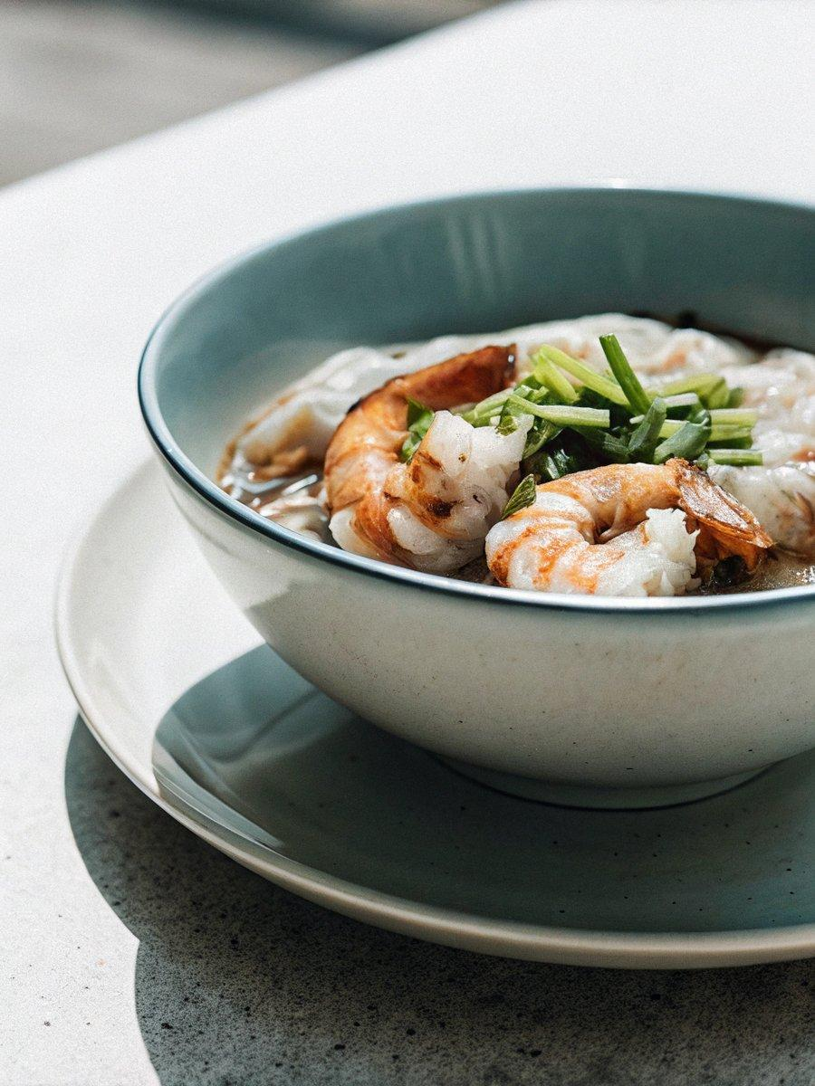

INGREDIENTS  - 1 cup (240ml) rice flour  - 1/2 cup wheat starch  - 1/2 tsp salt  - 3 cups (720ml) water  - 1/2 lb shrimp , peeled and deveined  - 2 scallions , sliced (greens only)  - 1/2 tbsp cornstarch  - 1/2 tbsp water  - 1/4 tsp salt  - 1/4 tsp sugar  - 1/4 tsp toasted sesame oil  - Pinch of white pepper  - 1 tsp vegetable oil  - 2 scallions , sliced into 2” (5-cm) pieces (white part only)  - 2 garlic cloves  - 5 tbsp water  - 2 tbsp light soy sauce  - 1 tbsp dark soy sauce  - 2 tbsp sugar  - 1 tbsp oyster sauce  - 2 dried shiitake mushrooms  - Pinch of white paper  - Large wok (or large deep skillet with cover)  - Stainless steel tray , that can fit into your wok or skillet  - Steaming rack  - Bench scraper  - Brush | PREP  COOK  1. To make the batter: Combine the rice flour, wheat starch and salt in a large bowl. Mix with a whisk. Pour in the water. Mix until the flour is fully incorporated. Let the flour hydrate while preparing the rest of the ingredients.  2. To make the filling: Slice the shrimp across the center lengthwise in half, then slice across vertically into 2/3” (1.5 cm) pieces. (*Footnote 1) Transfer the shrimp into a medium bowl, add the scallion greens, cornstarch, water, salt, sugar, sesame oil and white pepper. Mix well and set aside to marinate.  3. To make the sauce: Heat the oil over medium heat in a small pot until hot. Add the scallions. Let cook until the surface turns lightly golden, 1 to 2 minutes. Then add the garlic. Cook for another minute, until the garlic turns golden brown. Add the water, light and dark soy sauce, sugar, oyster and shiitake mushrooms. Stir to mix. Keep cooking until the sauce is boiling and the sugar has melted. Remove the pot from the stove. Leave with the aromatics in the pot to infuse the flavor, until the sauce has fully cooled. Strain the sauce into a small bowl.  4. Make the cheung fun  5. Set up the steamer: In a large wok, place a steaming rack in the center, and place a rectangular stainless steel tray onto the rack, the short side facing you. Make sure the wok lid can cover the wok properly. (Footnote 2) Keep the tray as leveled as you can. Fill the wok with water until just below the rectangular tray. Heat over high heat until the water is boiling. Keep the wok covered to heat up the stainless tray for at least 5 minutes, until very hot.  6. To make cheung fun: Brush a thin layer of vegetable oil across the tray. Stir the batter before using every time, so the rice flour is fully incorporated. Pour 1/3 cup of batter onto the tray. (*Footnote 3) Use the cup to disperse the batter to cover the tray. You can also use a dish towel to hold the tray, and tilt the tray to evenly spread out the batter. Pour in a little more batter to fully cover the tray, if needed. (*Footnote 4) Cover and cook for 1 minute, until the batter just sets but is not fully cooked.  7. Add the filling: Place approximately 2 tablespoons worth of filling in a tight row on the cheung fun batter, about a third of the way up, across the short side of the pan facing you. Cover again and steam for an additional two minutes, until the shrimp is fully cooked and the cheung fun is set.  8. Roll the cheung fun: Use a dish towel to transfer the steaming tray from the wok onto a clean work surface. Keep the wok covered. Using a bench scraper, first gently separate the cheung fun from the tray’s sides. Then use the bench scraper to roll the cheung fun, starting with the side that the shrimp are closest to. Gently lift the cheung fun from the tray’s edge, and roll until a cylinder is formed. (*Footnote 5) If the cheung fun is having trouble lifting off the tray once rolled, gently tip the tray over a plate, so the roll comes off the tray in one piece.  9. To make the rest cheung fun: Place the stainless tray back into the wok. Reheat for a few minutes until hot before using. Repeat the process until all the batter and shrimp are used up.  1  0. To serve: Pour a few spoonfuls of the seasoned soy sauce over the cheung fun. Serve warm as an appetizer or a snack.  1  1. Store and reheat: You can keep the cheung fun in an airtight container in the fridge for 1 to 2 days, or in the freezer for a month. Steam to reheat until heated through.  PLATING

