ROASTED CAULIFLOWER STEAKS WITH HARISSA AND CHERMOULA  COOK TIME: 30 min  SOURCE:  #roasted #spicy #vegetable | 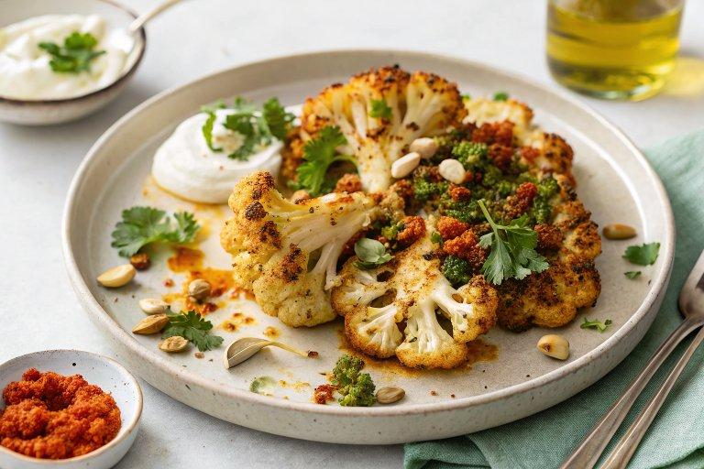

INGREDIENTS  - 3 tbsp harissa paste  - 2 large garlic cloves, (crushed or minced)  - 1 tbsp honey  - 1 tsp dried oregano  - 1/2 lime, (juiced)  - 1 tbsp Greek yogurt  - 1 large cauliflower  - Salt  - Black pepper  - Extra virgin olive oil, (for drizzling)  - 1 cup (240ml) fresh cilantro leaves and tender stems  - 1/2 cup parsley leaves and tender stems  - 1 small preserved lemon, (seeds removed and coarsely chopped (rind and all)  - 1/2 tsp ground cumin  - 1/4 tsp sweet or smoked paprika  - Small pinch of Aleppo pepper  - 1/2 lime, (juiced)  - 1 to 2 tsp honey  - Salt  - Black pepper  - 1/2 cup extra virgin olive oil, (plus more as needed) | PREP  COOK  1. Get ready. Preheat your oven to 400°F (200°C).  2. Make the harissa glaze. In a small bowl, add the harissa paste, garlic, honey, oregano, lime juice, and yogurt. Whisk until fully combined.  3. Dress the cauliflower. Remove the cauliflower’s outer leaves at the base, then into 1-inch (3cm) thick planks. Place on a baking tray and season with salt and pepper. Then brush each side generously with the harissa glaze.  4. Roast the cauliflower. Drizzle the cauliflower steaks with olive oil and bake on the center rack until tender and a little charred, about 30 minutes.  5. Start the Chermoula. Meanwhile, in a food processor fitted with a blade, pulse the cilantro and parsley until they are coarsely chopped. Then add the preserved lemon, cumin, paprika, Aleppo pepper, lime juice, honey, and salt and pepper to taste.  6. Blend. With the food processor on low speed, and drizzle in the olive oil. Watch it as it blends. This step should not take very long at all. Don’t over-process the mixture; chermoula is not meant to be a runny sauce! It should still have a little texture to it at the end. Once it looks like the flavors have melded, turn off your food processor. Taste a little and adjust the seasoning or lime juice to your taste.  7. Assemble and serve. When the cauliflower steaks are cooked to your liking, remove the tray from the oven. Spread the cauliflower steaks onto your serving dish and then spoon the chermoula dressing over top just before serving.  PLATING

